# GETTING STARTED

## Setting up development environment

* Download and install JDK and Java Runtime Environment
* Download and install IDEA (IntelliJ)

## Anatomy of a Java Program

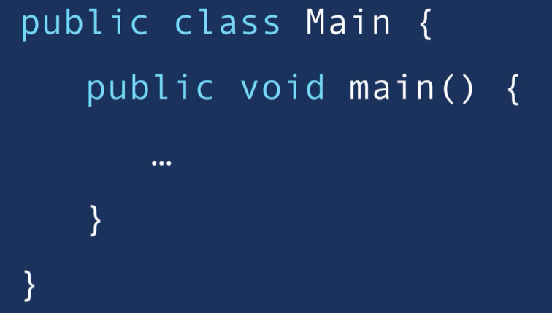

### Naming Conventions:

* Classes
  + PascalNamingConvention
* Methods
  + camelNamingConvention

## How Java Code Gets Executed

Two Steps:

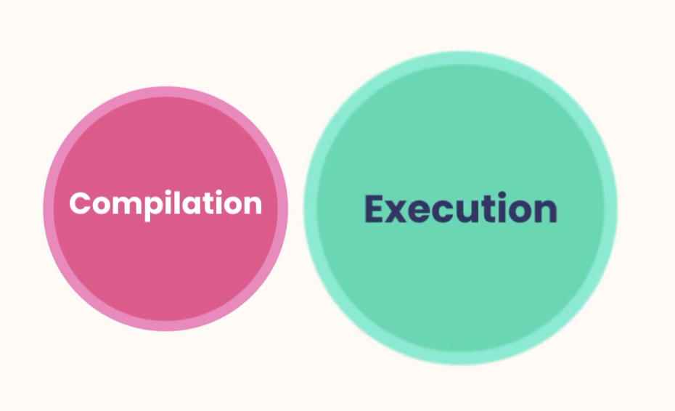

## Compilation

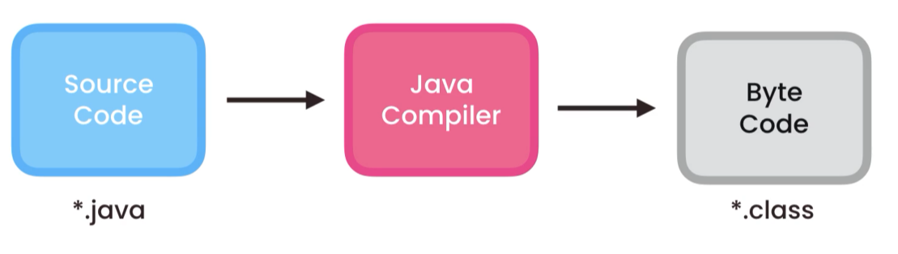

Note: Java compiler comes in the JDK

We could run in the terminal,

* right click on Main.java
* cmd javac Main.Java (javac = compiler)
* Main.class it is created – Byte Code

## Java Runtime Environment

The byte code can run in any environment Windows, Mac OS, Linux as long as it has a Java Runtime Environment JRE (Java)

The JRE has a Java Virtual Machine **JVM** that translate our byte code to the OS.

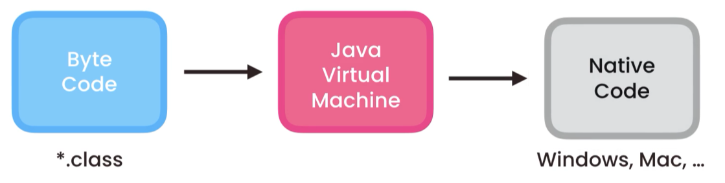

#### Invoking JVM

In terminal go to src repo after compiling

* CMD java fullPath to Our Main Class file (ByteCode)
  + Example: java ca.adrian.Main

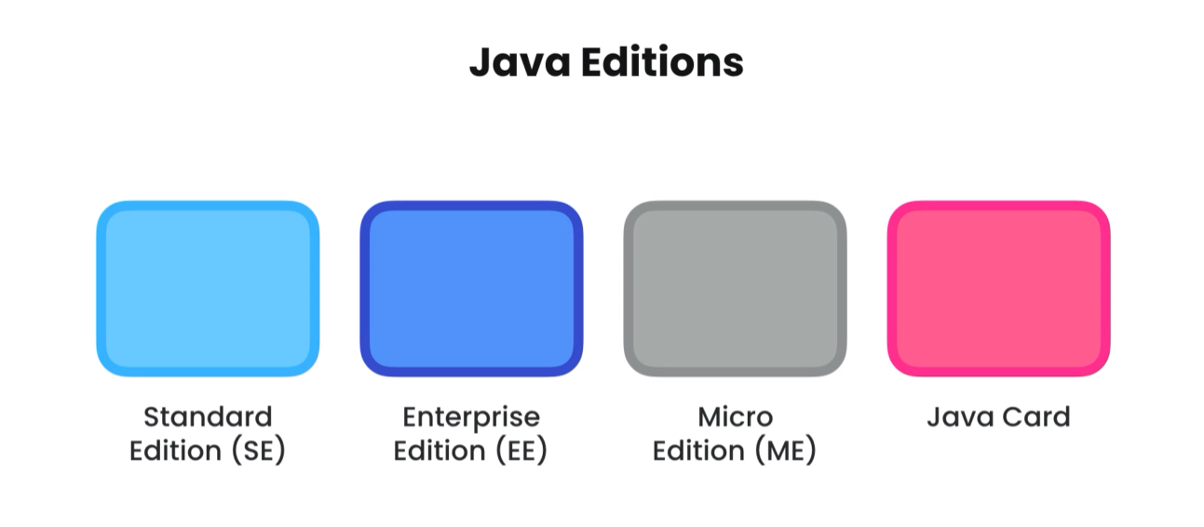

# TYPES

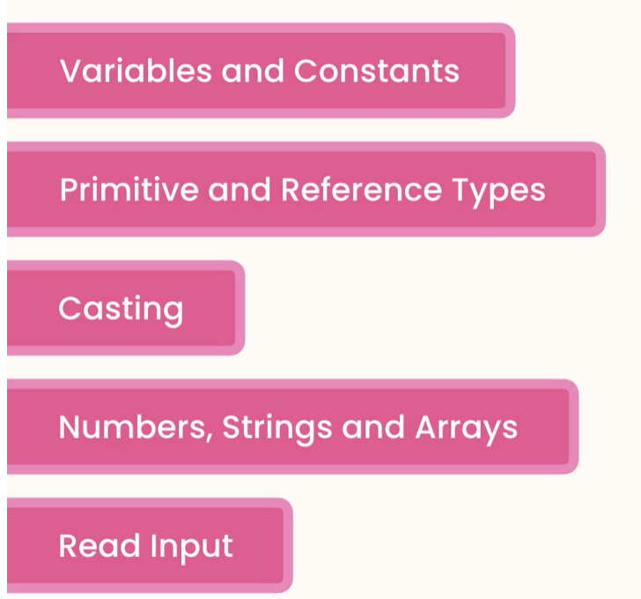

# Variables

Variables use camelConvetionNaming

### Table Description automatically generatedPrimitive Types

Examples Declaration and Initialization:

byte age = 38;

long viewsCount = 3_123_456_789L;

float price = 10.99F;

char letter = 'A';

boolean isEligible = true;

## Reference Types

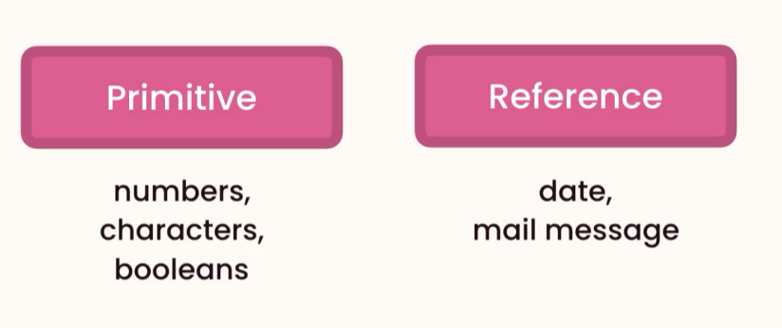

*// Reference Type*Date now = new Date(); // instance of Date class  
System.*out*.println(now);

new allocates memory for the new object

### Primitive vs Reference Types

**Memory Management**

**Primitive Type**: Are completely independent from each other since they have different memory locations

int x = 1;  
int y = x;  
x = 5;  
System.*out*.println(y);

output: 1

Primitive types are copied by their values.

#### **Reference Type:** Are dependent of each since they are referring the same object by memory location address

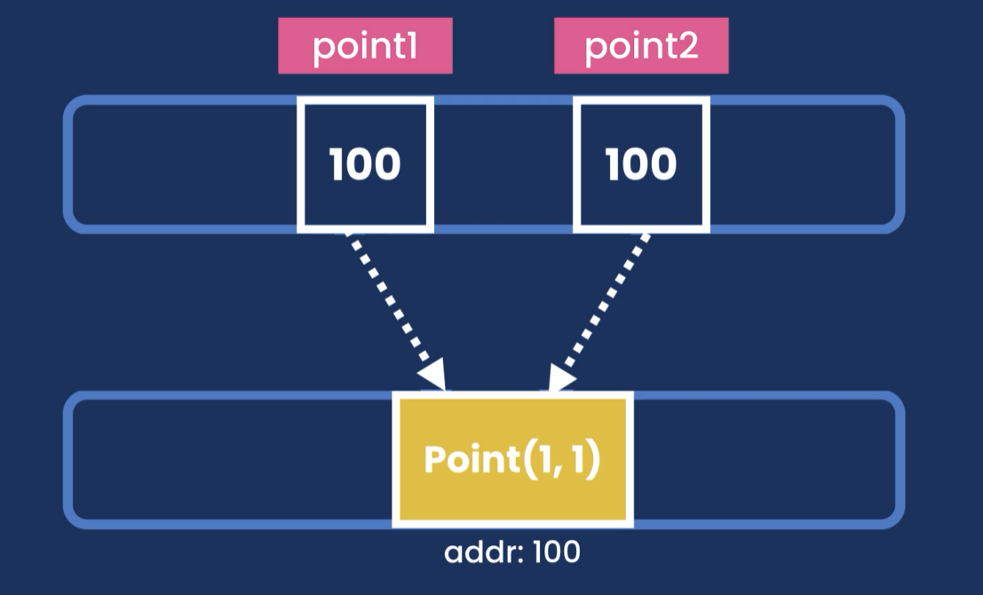

Point point1 = new Point(1,1);  
Point point2 = point1;  
point1.x = 2;  
System.*out*.println(point2);

output: 2

Reference types are copy by their references (Address in the heap memory)

## Strings

String are immutable, cannot be changed.

All methods that modify a string will return a new String object.

String message = "Hello World" + "!!";  
String message2 = message.replace('!', '?');

System.*out*.println(message2); -> Hello World??  
System.*out*.println(message); -> Hello World!!

## Scape Sequences

\” -> “

String message = "Hello \"Adrian\"";

Hello “Adrian”

\\ -> \String path = "C:\\Users\\adria\\OneDrive\\Documents";  
System.*out*.println(path);

C:\Users\adria\OneDrive\Documents

\n -> newline

\t -> Tab

## Arra ys

Arrays are reference types, so we need to use new keyword to allocate memory in the heap

Declaring and initializing an array using

**Old syntax**

int[] numbers = new int[5];

We can access each individual item by index  
numbers[0] = 1;  
numbers[1] = 2;

System.*out*.println(Arrays.*toString*(numbers));

Output: [1, 2, 0, 0, 0]

**New syntax**

int[] numbers = {2, 3, 5 , 1, 4};

System.*out*.println(numbers.length);

Numbers of items in a array: 5

In Java arrays have a fixed size, once created we can not add or remove.

**FIX LENGTH**

### Multi dimensional arrays MATRIX

We use Arrays. deepToString(array) -> to print multidimensional arrays

Each row is an array itself

**Old syntax**int[][] numbers = new int[2][3]; *// 2 rows and 3 columns*numbers[0][0] = 1;  
System.*out*.println(Arrays.*deepToString*(numbers));

output: [[1, 0, 0], [0, 0, 0]]

-----------------------------------------------------------------------------

**New syntax**

int [][] numbers2 = {{1,2,3},{4,5,6}};  
System.*out*.println(Arrays.*deepToString*(numbers2));

output: [[1, 2, 3], [4, 5, 6]]

## Constants

We use the keyword: final

final float PI = 3.14F;

The values of a constant cannot be changed in another part of the code.

## Arithmetic Expressions

In Java we have the following arithmetic operations

* +, -, *, /, %

When dividing two whole numbers java will give a result of a whole number

We need to cast explicit casting to get the desired decimal result

Example:

double result = (double)10 / (double)3;  
System.*out*.println(result);

Output: 3.3333333333333335

We have increment and decrement operators

* ++
* --

We can apply the operators as post fix or prefix

Example

++x;

x++;

int x = 1;  
int y = x++;  
System.*out*.println(y);

output 1;

int x = 1;  
int y = ++x;  
System.*out*.println(y);

output : 2

##### Augment | compound operators.

* +=, -=, *=, /=

Example:

x += 2;  
System.*out*.println(x);

output: 3

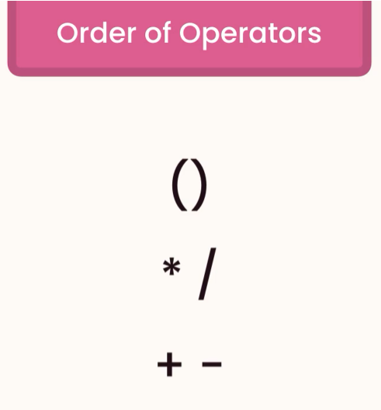

## Casting

*// Implicit Casting - automatic  
// byte > short > int > long > float > double*double x = 1.1;  
double y = x + 2; *// converts 2 > 2.0 then sum*

Output: 3.1

// Explicit casting

double x = 1.1;  
int y = (int)x + 2; *// x > int = 1*

output = 3

Implicit casting can happen only between compatible types

Examples:

All numbers (*byte > short > int > long > float > double*)

We can use Wrapper classes to parse from string to number

Integer, Float, Double, …

And use the method parse

Example:

String x = "1";  
int y = Integer.*parseInt*(x) + 2;

# The Math Class

Java.lang package

Reference: <https://docs.oracle.com/javase/8/docs/api/java/lang/Math.html>

This class is packed with static methods to use in different mathematical calculation

Example of some static methods:

int resultCeil =(int) Math.*ceil*(1.1F);  
int resultMax =(int) Math.*max*(3, 5);  
int resultRandom = (int)Math.*round*(Math.*random*()*100);

# Formatting Numbers

Class: **NumberFormat** can be used to format numbers, this class is an abstract class so we cannot instantiate it using the new keyword, instead we use get factory methods.

NumberFormat currency = NumberFormat.*getCurrencyInstance*();

java.text.NumberFormat

Example:

NumberFormat currency = NumberFormat.*getCurrencyInstance*();  
NumberFormat percentage = NumberFormat.*getPercentInstance*();  
String resultPercentage = percentage.format(234.5666);  
String resultCurrency = currency.format(123456.789);

# Reading Inputs SCANNER CLASS

Scanner scanner = new Scanner(System.*in*); *// we must specify where are reading the data from terminal | file*System.*out*.print(question);  
byte age = scanner.nextByte();  
System.*out*.println("\nYou are " + age + " years old.");

System.*out*.print("Name: ");  
String name = scanner.nextLine().trim();  
System.*out*.println("Your full name is " + name + ".");

# Project- Mortgage Calculator

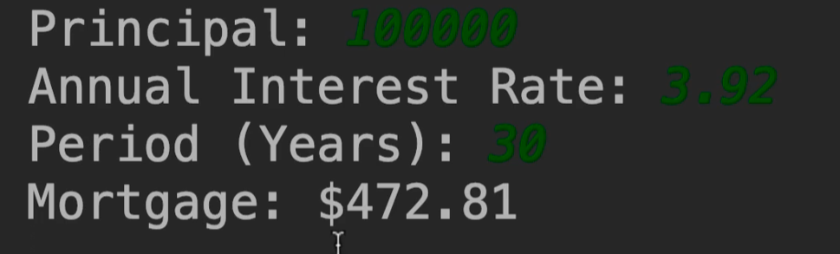 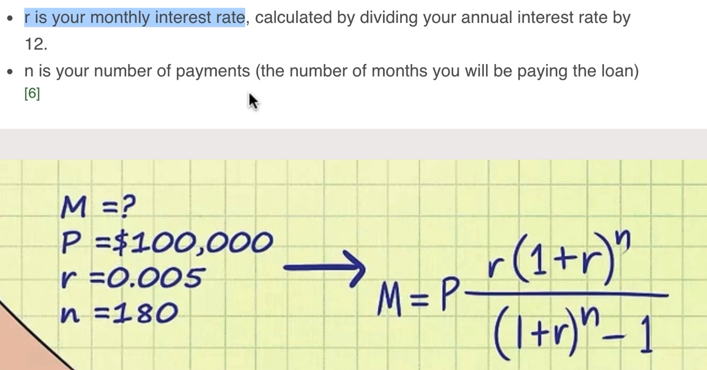

private static void getMortgagePayment() {  
 final byte MONTHS_IN_YEARS = 12;  
 final byte PERCENT = 100;  
 Scanner scanner = new Scanner(System.*in*);  
 float principal;  
 float monthlyInterestRate;  
  
 System.*out*.print("Principal: ");  
 principal = scanner.nextFloat();  
  
 System.*out*.print("Annual Interest Rate: ");  
 monthlyInterestRate = scanner.nextFloat() / PERCENT / MONTHS_IN_YEARS;  
  
 System.*out*.print("Period (Years): ");  
 byte years = scanner.nextByte();  
 int numberOfPayments = years * MONTHS_IN_YEARS;  
  
 float mortagePayment = (float) (principal  
 * (monthlyInterestRate * Math.*pow*(1 + monthlyInterestRate, numberOfPayments))  
 / (Math.*pow*(1 + monthlyInterestRate, numberOfPayments) - 1));  
  
 *// formatting number* String mortagePaymentFormatted = NumberFormat.*getCurrencyInstance*().format(mortagePayment);  
 System.*out*.println("Mortgage:" + mortagePaymentFormatted);  
  
}

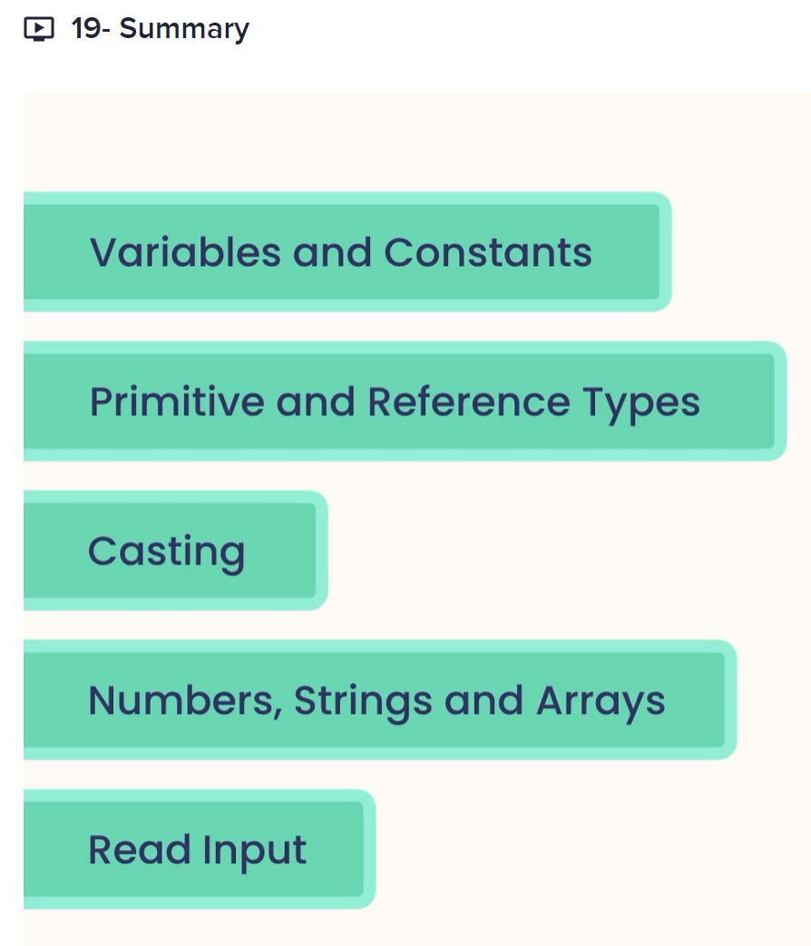

# CONTROL FLOW

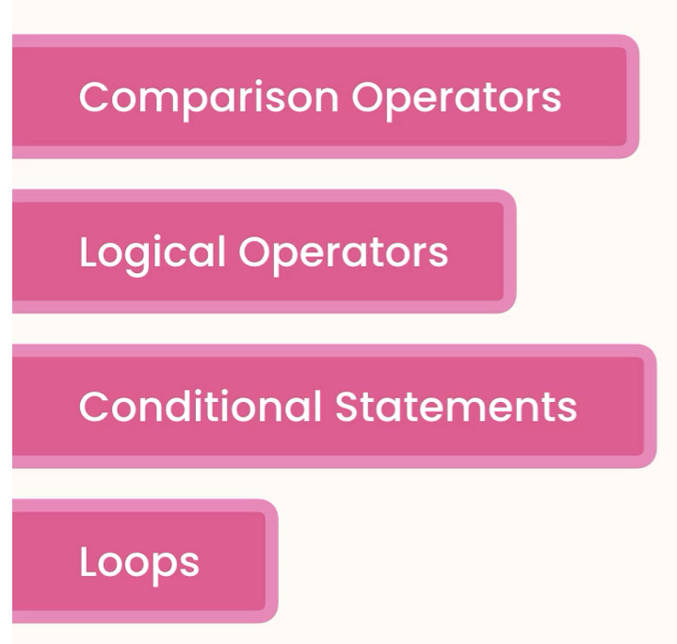

# Comparison Operators

We use comparison operators to compare primitive values.

* !=
* ==
* >
* >=
* <
* <=

# Logical Operators

* &&
* ||
* !

Example

int temperature = 22;  
boolean isWarm = temperature > 20 && temperature < 30; *// both condition must be true*System.*out*.println(isWarm);  
  
boolean hasHighIncome = true;  
boolean hasGoodCredit = true;  
boolean hasCriminalRecord = false;  
boolean isEligible = (hasHighIncome || hasGoodCredit) && !hasCriminalRecord; *// if one condition is true then returns true*System.*out*.println(isEligible);

# IF Statements

Implement using if statements the following:

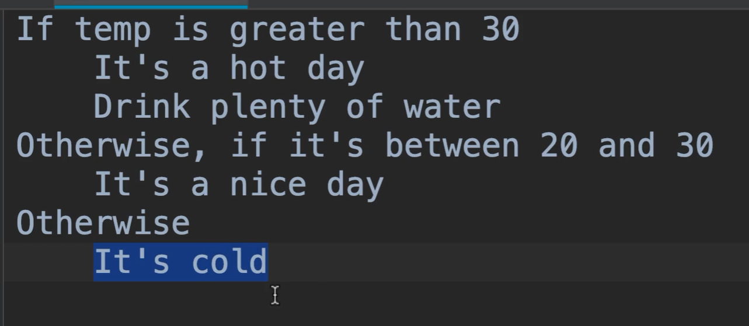

int temp = 19;  
  
if (temp > 30){  
 System.*out*.println("It is a hot day\nDrink plenty of water.");  
} else if (temp > 20 && temp < 30){  
 System.*out*.println("It is a nice day.");  
} else{  
 System.*out*.println("It is cold.");  
}

## Simplifying if statements

int income = 120_000;  
boolean hasHighIncome = (income > 100_000);

## The Ternary Operator

int income = 120_000;  
String className = income > 100_000? "First" : "Economy"; *// syntax condition? true : false;*

# Switch Statements

*// Switch Statements*String role = "admin";  
  
switch (role){  
 case "admin":  
 System.*out*.println("You are an admin.");  
 break;  
 case "moderator":  
 System.*out*.println("You are a moderator.");  
 break;  
 default:  
 System.*out*.println("You are a guest.");  
}

FizzBuzz

*/*  
 If number is divisible  
 by 5: Fizz  
 by 3: Buzz  
 by both 5 && 3: FizzBuzz  
 not divisible bye either: get the number  
 */*public static void fizzBuzz(){  
 Scanner scanner = new Scanner(System.*in*);  
  
 System.*out*.print("Number: ");  
 int number = scanner.nextInt();  
  
 if (number % 5 == 0 && number % 3 == 0)  
 System.*out*.println("FizzBuzz");  
 else if (number % 5 == 0)  
 System.*out*.println("Fizz");  
 else if (number % 3 == 0)  
 System.*out*.println("Buzz");  
 else  
 System.*out*.println(number);  
}

# For Loops

*// For Loops – used when knowing the times we will repeat the loop*for (int i = 5; i > 0; i--)  
 System.*out*.println("Hello World " + i);  
  
for (int i = 0; i < 6; i++)  
 System.*out*.println("Hello Adrian " + i);

For(counter (1) ; boolean expression (2); counter increment | decrement (4)){

… (3)

}

# While Loops

While loops are used in a situation where we do not know how many times we will repeat the loop

Example:

Scanner scanner = new Scanner(System.*in*);  
String input = "";  
int counter = 0;  
  
while (!input.equals("quit")){  
 System.*out*.println("\nType one of the following options and press ENTER");  
 System.*out*.println("1. Quit");  
 System.*out*.println("2. Print new line.");  
  
 int userRequest = scanner.nextInt();  
  
 if (userRequest < 1 || userRequest > 2){  
 System.*out*.println("Enter correct value");  
 continue;  
 }  
  
 switch (userRequest){  
 case 1:  
 System.*out*.println("Bye");  
 input = "quit";  
 break;  
 case 2:  
 counter++;  
 System.*out*.println("Hello user!!!" + counter);  
 continue;  
 }  
  
}

# Do While Loops

int i = 10;  
do {  
 System.*out*.println(i);  
 i--;  
}while (i > 0);

# Break and Continue Statement

**break** => Java ignores everything after and terminates the loop.

**continue** => goes back to start another loop.

Scanner scanner = new Scanner(System.*in*);  
String input = "";  
  
while (true){  
 System.*out*.print("Input: ");  
 input = scanner.next().toLowerCase();  
  
 if (input.equals("pass"))  
 continue;  
  
 if (input.equals("quit"))  
 break;  
  
 System.*out*.println(input);  
}

# For-Each Loop

*// For-Each Loop*String [] fruits = {"Apple", "Mango", "Orange"};  
  
for (String fruit: fruits){  
 System.*out*.println(fruit);  
}

Syntax:

For(ArrayType variableName: Array){

System.*out*.println(variableName);

}

Limitations:

* Can iterate forward only
* No access to the index

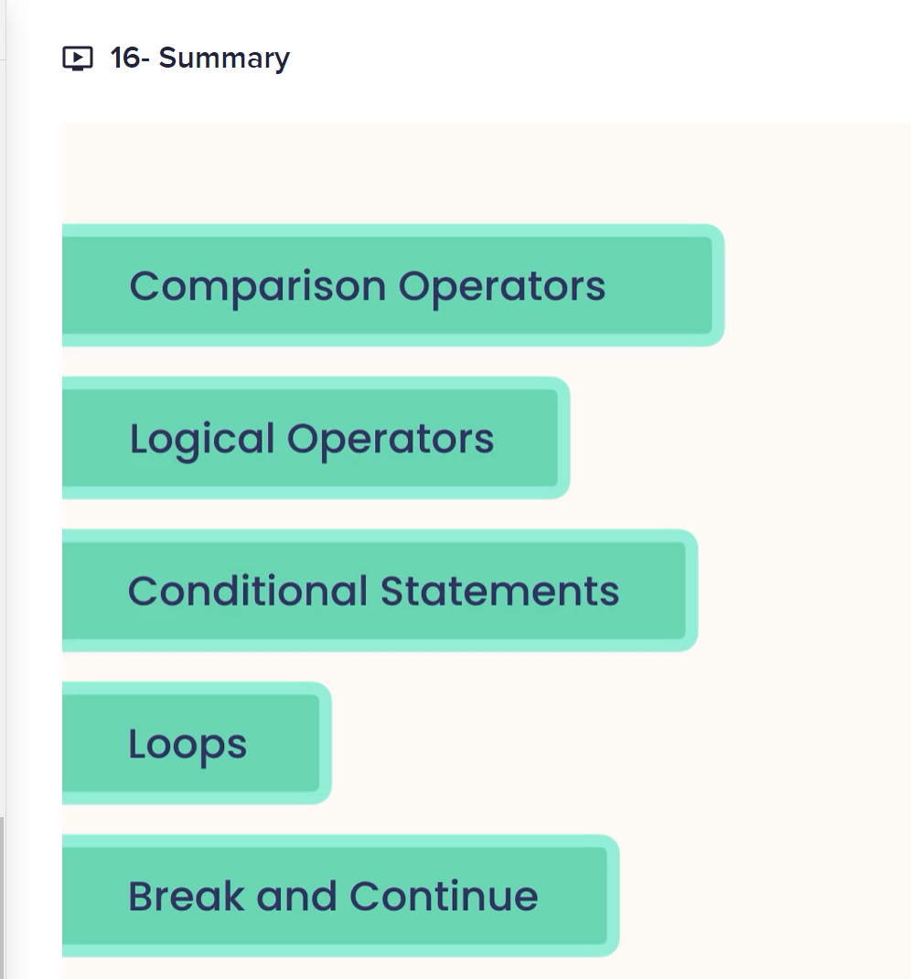

# CLEAN CODING

**Refactoring:** Changing the structure of our code without changing its behavior

**Methods:** should be 5 – 20 lines of code

**DRY** -> Don’t repeat yourself

When we are going to refactor, we should look at the lines of codes that always go together.

We extract methods whenever possible

# DEBUGGING AND DEPLOYING JAVA APPLICATIONS

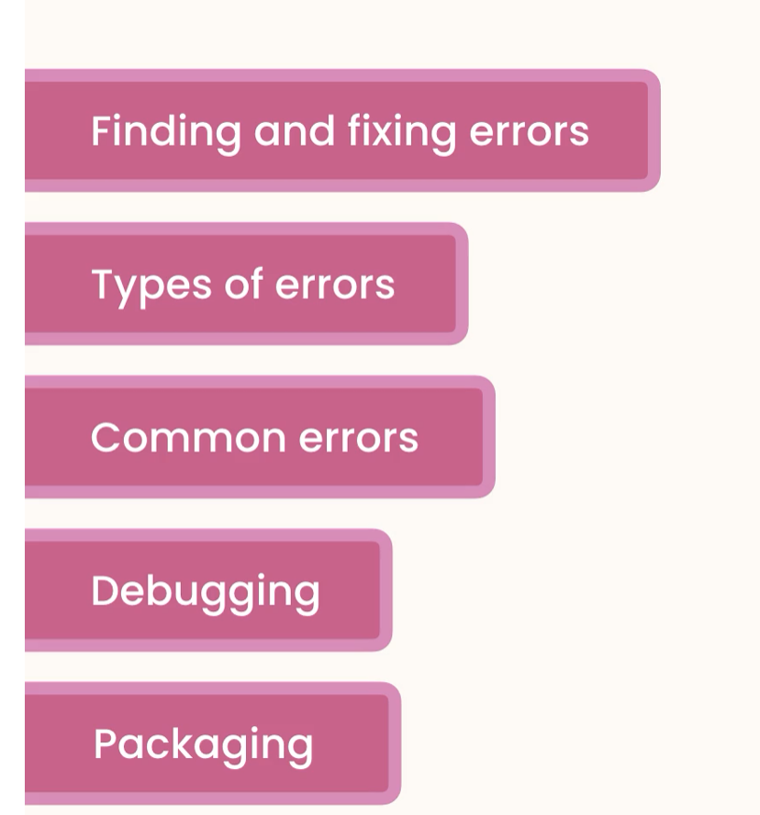

## Types of Errors

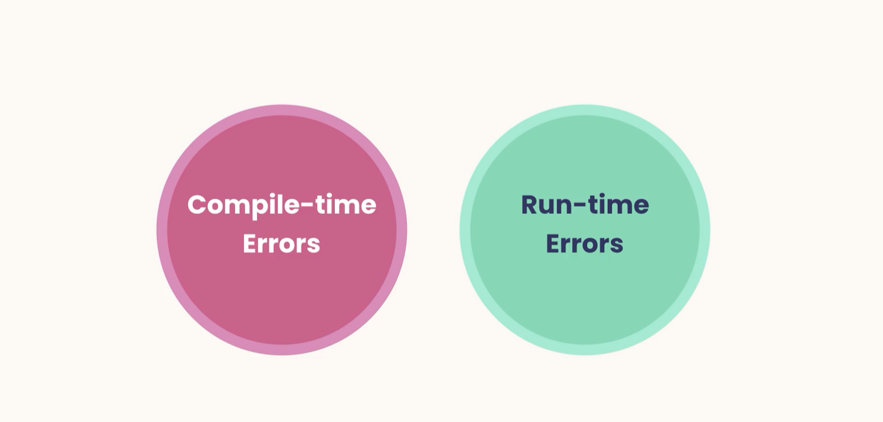

## Deploying console application

1. Package your file into JAR file
   1. Add artifact select Main class

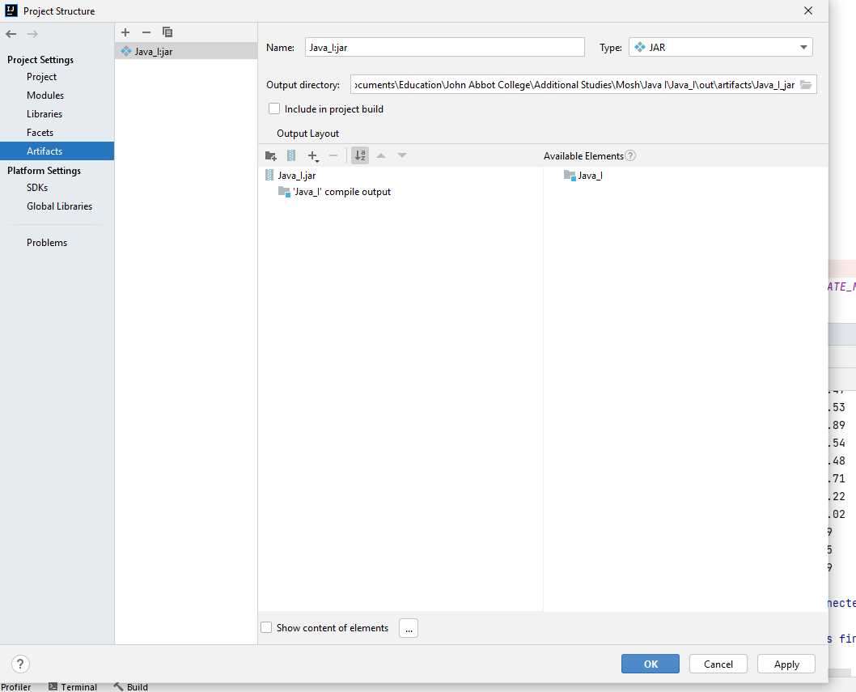

1. Build Artifact

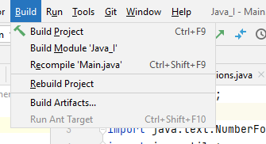

1. 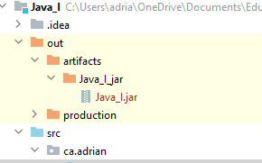

It can be run in terminal

Cmd => java -jar Java_I.jar

# GETTING STARTED

## Programming Paradigms

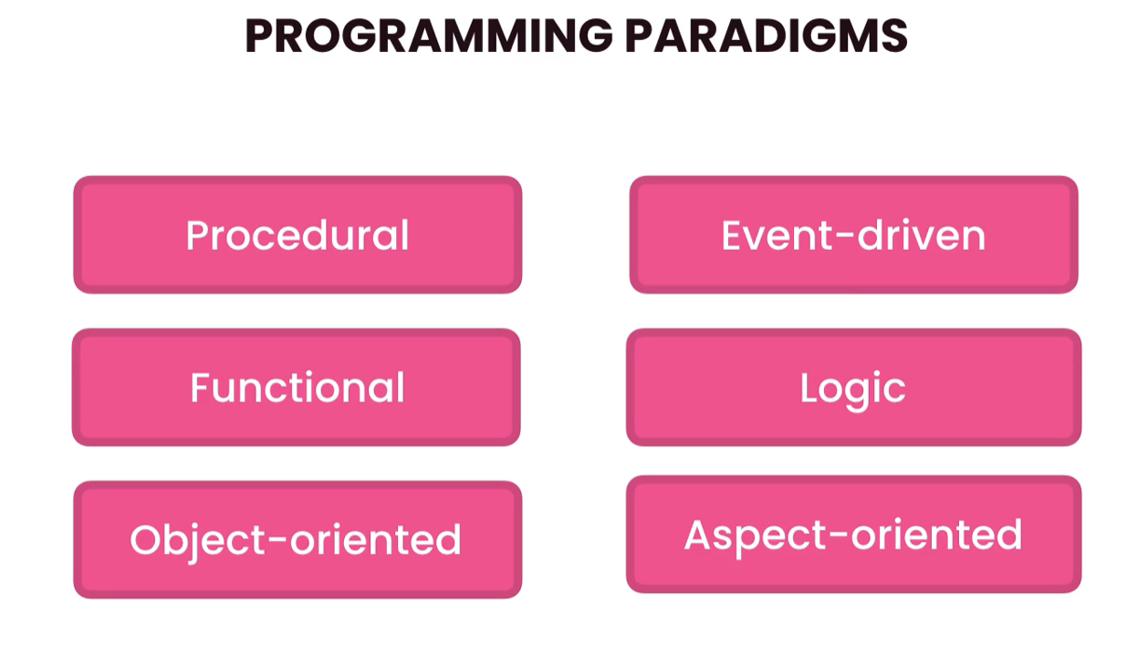

### Object Oriented Programming



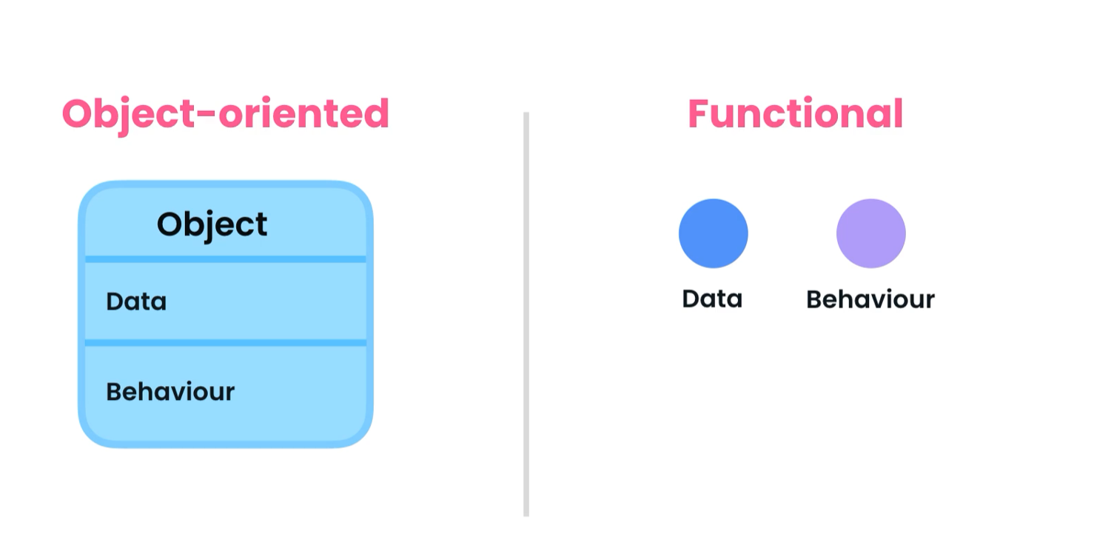

What is the best paradigm? | It depends on the problem.

Problem Solving: Process of **defining a problem**, identifying and comparing **different solutions**, and picking the one that best solves that problem with respect to the **context** and **constraints**.

## Benefits of Object-oriented Programming

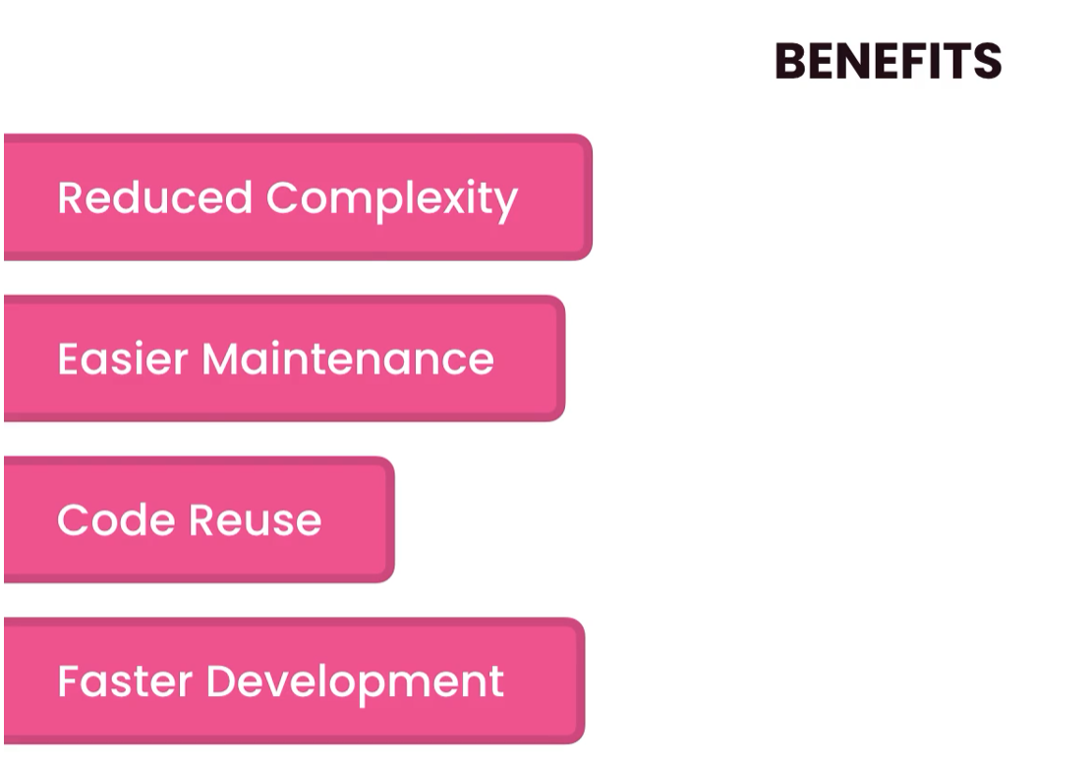

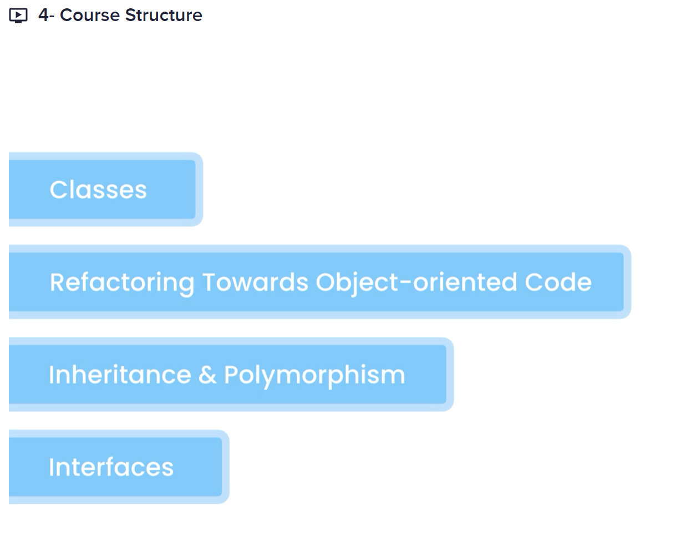

# CLASSES AND OBJECTS

Class: A blueprint for creating objects

Object: An instance of a class

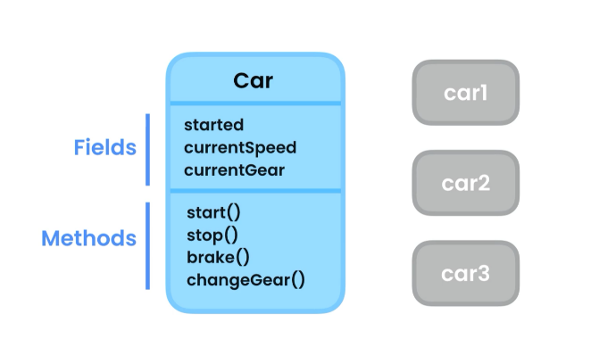 These objects *(car1, car2, car3)* are independent of

each other, each object has a different space in the

heap memory.

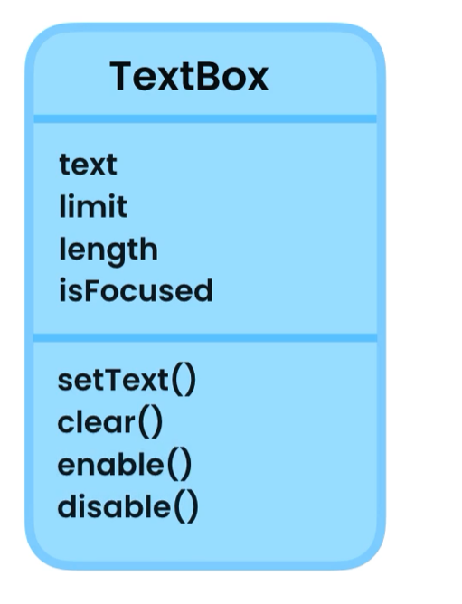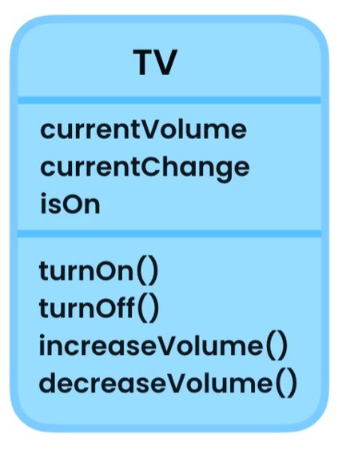

## Creating a class

Classes uses pascal naming convection **T**ext**B**ox, each letter of every word is capitalized

Syntax: public class TextBox{

}

Access modifier keyword class ClassName{}

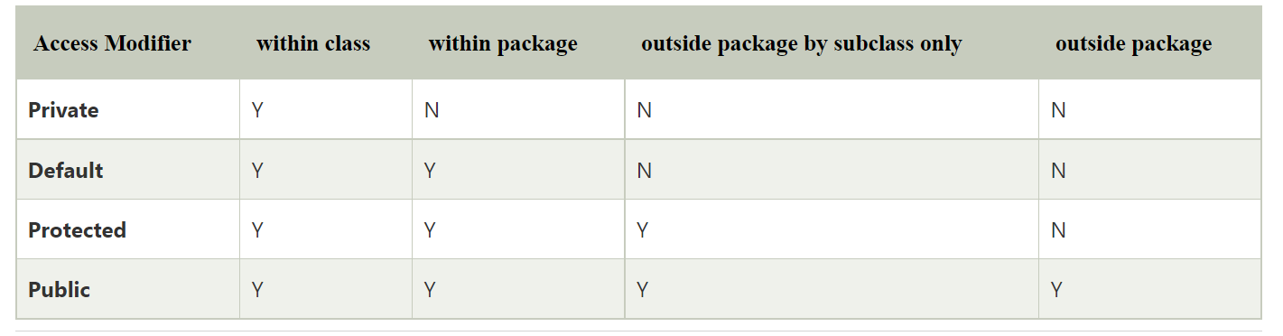

Inside the code block of the class

public class TextBox {  
 *// fields* public String text = "";  
  
 *// methods* public void setText(String text){  
 this.text = text; *// this -> this object* }  
  
 public void clear(){  
 text = "";  
 }  
}

## Initializing objects

var textBox1 = new TextBox();  
textBox1.setText("Box 1");  
System.*out*.println(textBox1.text.toUpperCase());  
  
var textBox2 = new TextBox();  
textBox2.setText("Box 2");  
System.*out*.println(textBox2.text);

OUTPUT:

BOX 1

Box 2

## Memory Allocation

Java manages two different area of the memory, the **HEAP** and **STACK** memory.

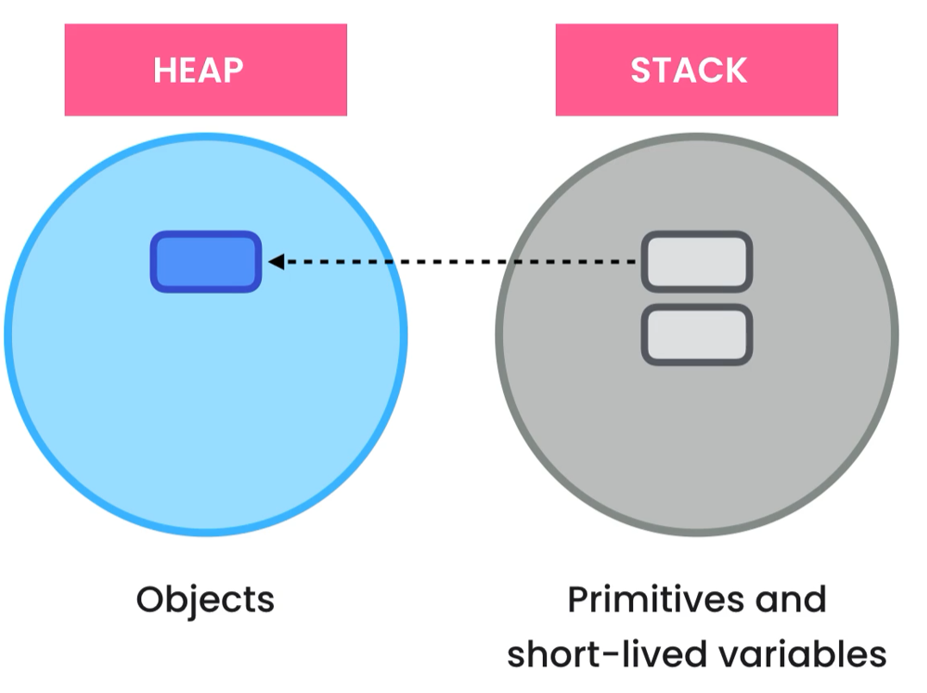

var textBox1 = new TextBox();  
textBox1.setText("Box 1");  
var textBox2 = textBox1;  
textBox2.setText("Hello World");  
System.*out*.println(textBox1.text);

Output: Hello World

Note: both variables are referring the same object in the heap, so changes will the object.

## Memory De-allocation

**Java runtime takes care of memory de-allocation**

**STACK:** Remove from the stack all variables and primitive types as soon as it reaches the end of the code block of the main method.

**HEAP:** Garbage collection will remove the object if the object is no used after a certain period.

## Encapsulation

Bundle the data and the methods that operate the data into a single unit called Class.

Use private modifier for fields so no access to them is possible, only through getters and setters

Example:

public class Employee {  
 *// fields* private int baseSalary;  
 private int hourlyRate;  
  
 *// methods* public int calculateWage(int extraHours){  
 return baseSalary + (extraHours * hourlyRate);  
 }  
  
 public void setBaseSalary(int baseSalary) throws IllegalArgumentException{  
  
 if (baseSalary <= 0)  
 throw new IllegalArgumentException("Salary must be greater than zero");  
 this.baseSalary = baseSalary;  
 }  
  
 public int getBaseSalary(){  
 return baseSalary;  
 }

## Abstraction

Reduce complexity by hiding unnecessary details in our classes.



With abstraction we hide the implementation of a class and treat it like a black box.

## Coupling

The level of dependency between classes

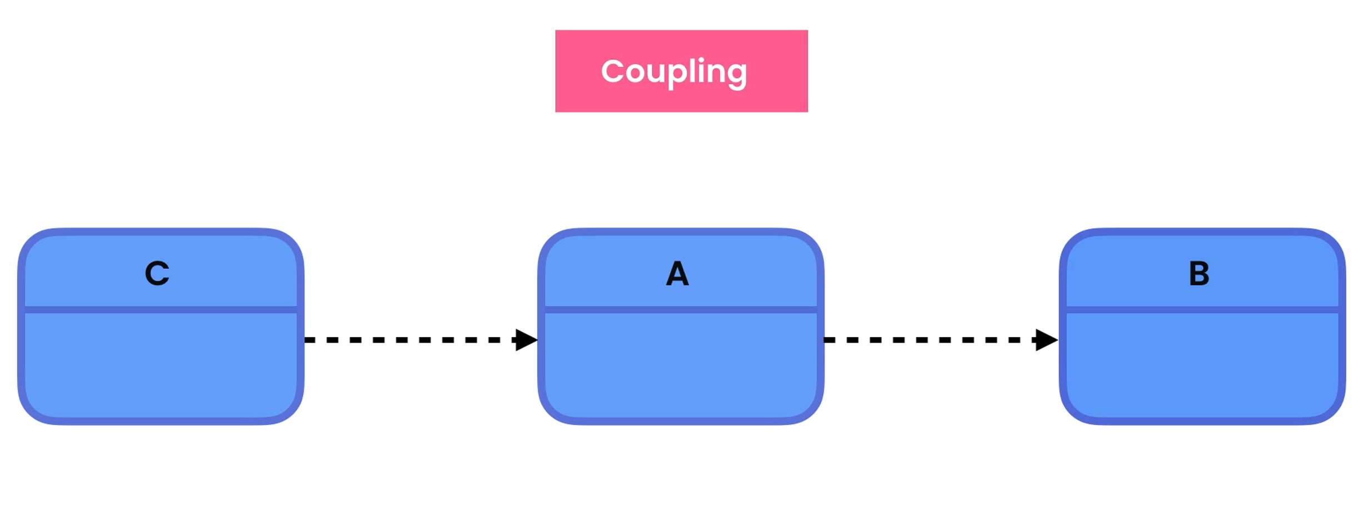

Reduction of coupling between classes whenever possible is good.

Reduce the number of methods in the class

## Reducing Coupling

A good approach to reduce coupling is to not expose methods that are only used in the class by other methods, so we declare private, and you wont access to it outside the class when making changes to the methods it won’t affect our application at all.

public class Browser {  
  
 public void navigate(String address){  
 String ip = findIpAddress(address);  
 String html = sendHttpRequest(ip);  
 System.*out*.println(html);  
 }  
  
 private String sendHttpRequest(String ip) {  
 return "<html>" +  
 "<h1>Hello Adrian</h1>" +  
 "</html>";  
 }  
  
 private String findIpAddress(String address) {  
 return "127.0.0.1";  
 }  
}

## Constructors

We use constructors to initialize our objects. If we do not create one, Java complier will create a default constructor and initialize our fields to default value:

* objects = null
* numbers = 0
* boolean = false

use abstraction as much as possible

*// constructors*public Employee(int baseSalary, int hourlyRate){  
 setBaseSalary(hourlyRate);  
 setHourlyRate(hourlyRate);  
}

We make our setter private, so no details are available outside this class.

## Method Overloading

It is when we need different implementation of the same methods with different parameters

Example:

public int calculateWage(int extraHours){  
 return baseSalary + (extraHours * hourlyRate);  
}  
  
public int calculateWage(){  
 return calculateWage(0);  
}

Constructor Overloading

*// constructors*public Employee(int baseSalary){  
 this(baseSalary, 0); *// calling the second constructor*}  
  
public Employee(int baseSalary, int hourlyRate){  
 setBaseSalary(baseSalary);  
 setHourlyRate(hourlyRate);  
}

To call a constructor from another constructor we use:

**this(arg1, arg2,…)**

Static Members

A class have two types of members:

* instance
  + belongs to instances of the class (objects)
    - employee.getName()
* static
  + belongs to the class not the object
    - Employee.numberOfEmployee;

We use static members when we want to represent a concept that will be in a single place (Class), a value is independent of objects

IMPORTANT: static methods can only call other static methods, the only way to have access is by creating an object to access it, since instance methods belongs to the object (instances of the class).

# REFRACTORING TO AN OBJECT-ORIENTED DESIGN

## The Problem

Analyse the problem and associated fields and methods, move them in classes separating the concern of each class, base on the concern separate classes.

Classes

* Console
* MortgageReport
* MortgageCalculator

# INHERITANCE

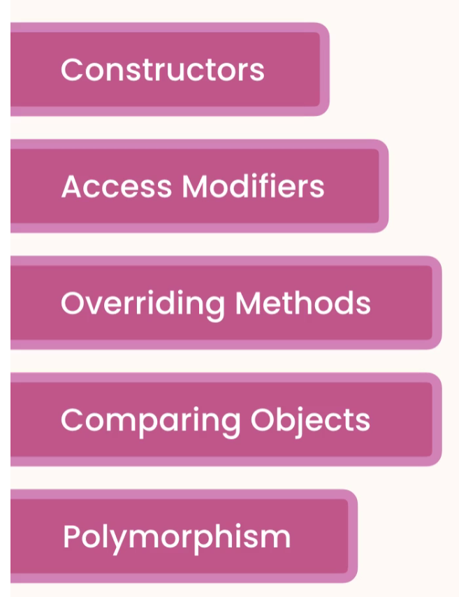

## Inheritance

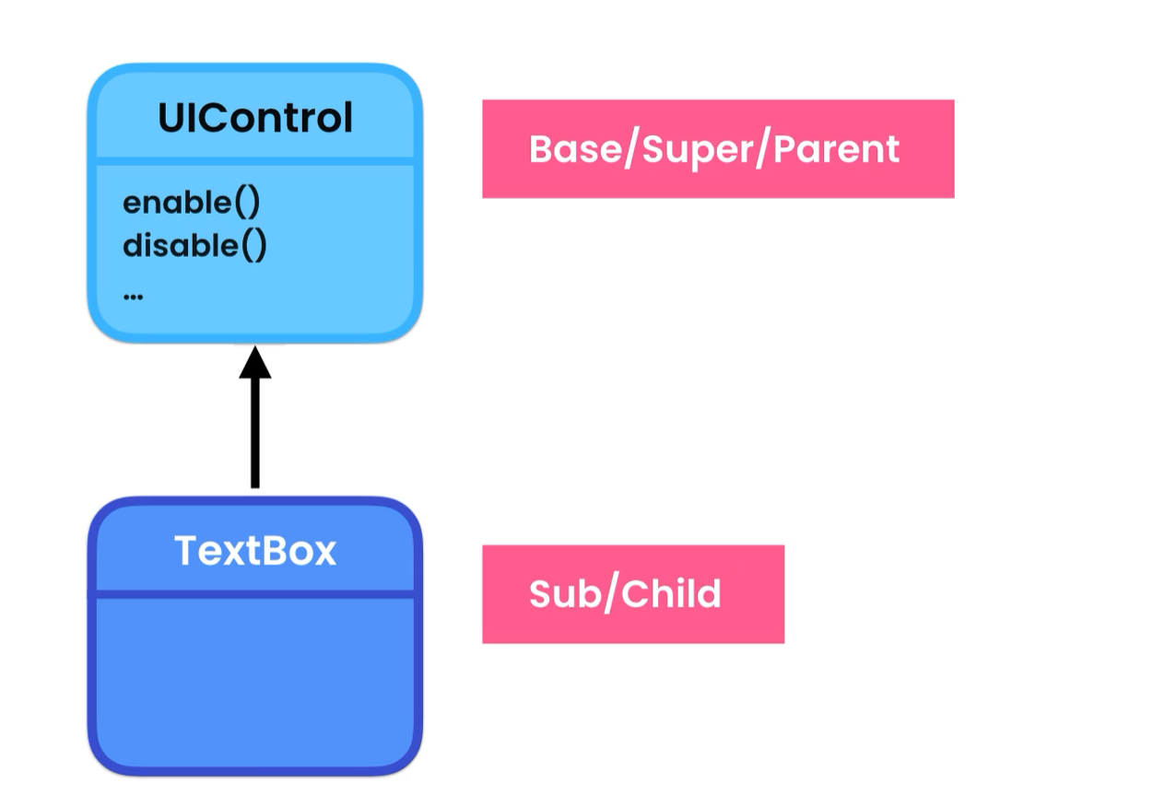

Inheritance is used for code reusability, when object share the same attributes, we declare de parent class and extend it in subclasses.

* We then have access to all data members of the parent class plus the subclass using extends

## The Object Class

Every class that we declare in Java directly or indirectly inherits from the Object Class, the java compiler does it automatically for us.

hashCode() -> integer calculated based on the address of the object in the heap memory

the equals() compare objects by hashCode

var box1 = new TextBox();  
System.*out*.println("box1 hashCode: " + box1.hashCode());  
var box2 = box1;  
System.*out*.println("box2 hashCode: " + box2.hashCode());  
System.*out*.println(box1.equals(box2)); //

--------------------------------------------------

Output:

box1 hashCode: 455659002

box2 hashCode: 455659002

true

--------------------------------------------------

Sometimes we want to compare the objects based on the attribute’s values and NOT the hashCode

### toString()

### -> string representation of an object which has two parts

[ca.adrian.TextBox@1b28cdfa](mailto:ca.adrian.TextBox@1b28cdfa)

1. ca.adrian.TextBox: fully qualify name of the object
2. @1b28cdfa: hashCode in hexadecimal

## Constructors and Inheritance

When creating a constructor in a subclass, we must call the parent constructor and pass the required arguments if any, the super() must be the first line in the subclass constructor.

public UIControl(boolean isEnabled) {  
 this.isEnabled = isEnabled;  
 System.*out*.println("UIControl");  
}

…

public class TextBox extends UIControl{  
 *// fields* private String text = "";  
  
 public TextBox() {  
 super(true);  
 System.*out*.println("TextBox");  
 }

## Access Modifiers

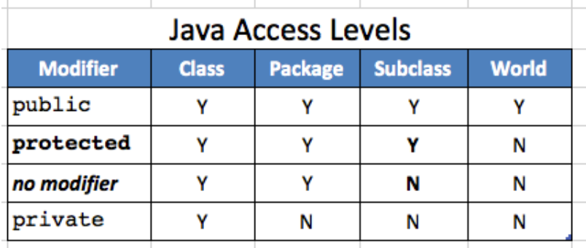

Protected and default is a bit of a code smell, not good practice to use it, better to stick to private and public access modifiers.

## Overriding Methods

When we change the implementation of a method. Example toString() we use the @Overrride annotation to give extra info to the compiler this way we will print the value of our object and not the string representation of the object -> ca.adrian.TextBox@1b28cdfa.

@Override *// annotation that gives the java compiler extra information*public String toString() {  
 return “Hola”;  
}

## Upcasting and Downcasting

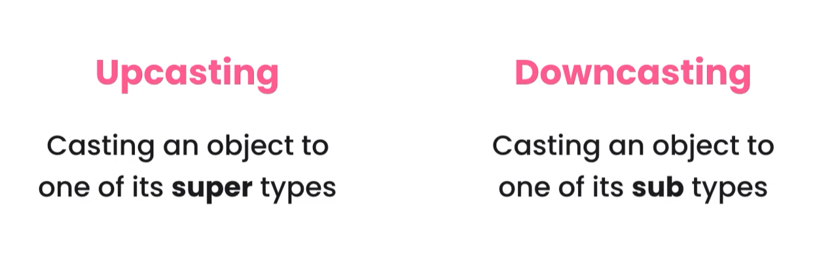

**Upcasting** -> (parent) child

**Downcasting** -> (child) parent

Inheritance represent - IS A RELATIONSHIP

public static void show(UIControl control){  
 if (control instanceof TextBox){  
 *// cast in order to have access to textBox members* var textBox = (TextBox) control;  
 textBox.setText("Hello from TextBox");  
 System.*out*.println(textBox);  
 }  
 else  
 System.*out*.println(control);  
}

## Comparing Objects

We can compare objects using the equals(), but this will compare the objects by hashCode.

To compare objects based on their data values, we can override the equals() like this:

public class Point {  
 private int x;  
 private int y;  
  
 public Point(int x, int y) {  
 this.x = x;  
 this.y = y;  
 }  
  
@Override  
public boolean equals(Object o) {  
 if (this == o) return true;  
 if (o == null || getClass() != o.getClass())  
 return false;  
 Point point = (Point) o;  
 return x == point.x && y == point.y;  
}  
  
@Override  
public int hashCode() {  
 return Objects.*hash*(x, y);  
}

}

## Polymorphism

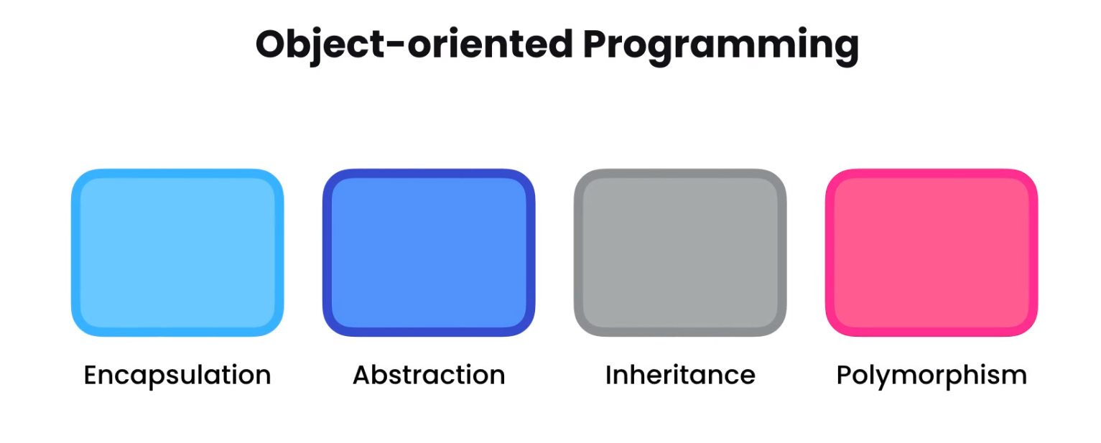



It allows an object to take many forms

Example:

// Parent Class

public class UIControl {  
 public void render(){} // declare default method no implementation

}

//Subclass-1

public class CheckBox extends UIControl{  
 @Override  
 public void render() {  
 System.*out*.println("Render CheckBox");  
 }  
}

//Subclass-2

public class TextBox extends UIControl{  
  
 @Override  
 public void render() {  
 System.*out*.println("Render TextBox");  
 }

}

MAIN:

public static void main(String[] args) {  
 UIControl[] controls = { new TextBox(), new CheckBox()};  
 for(UIControl control: controls)  
 control.render();  
}

**OUTPUT:**

**Render TextBox**

**Render CheckBox**

## Abstract Classes and Methods

**Abstract Class:** We use abstract classes when we don’t want to instantiate it but only extended.

**Abstract method:** it will force classes that extend the abstract class to implement it. The class must be abstract to have an abstract method.

Example: public abstract void render();

## Final Classes and Methods

**Final Class:** When we declare a class as final we cannot extended anymore.

**Final Method:** When a method is declared as final, we cannot override it.

Deep Inheritance Hierarchies



Inheritance is good but up to 3 level.

## Multiple Inheritance

Java does not support multiple inheritance.

**The diamond problem**

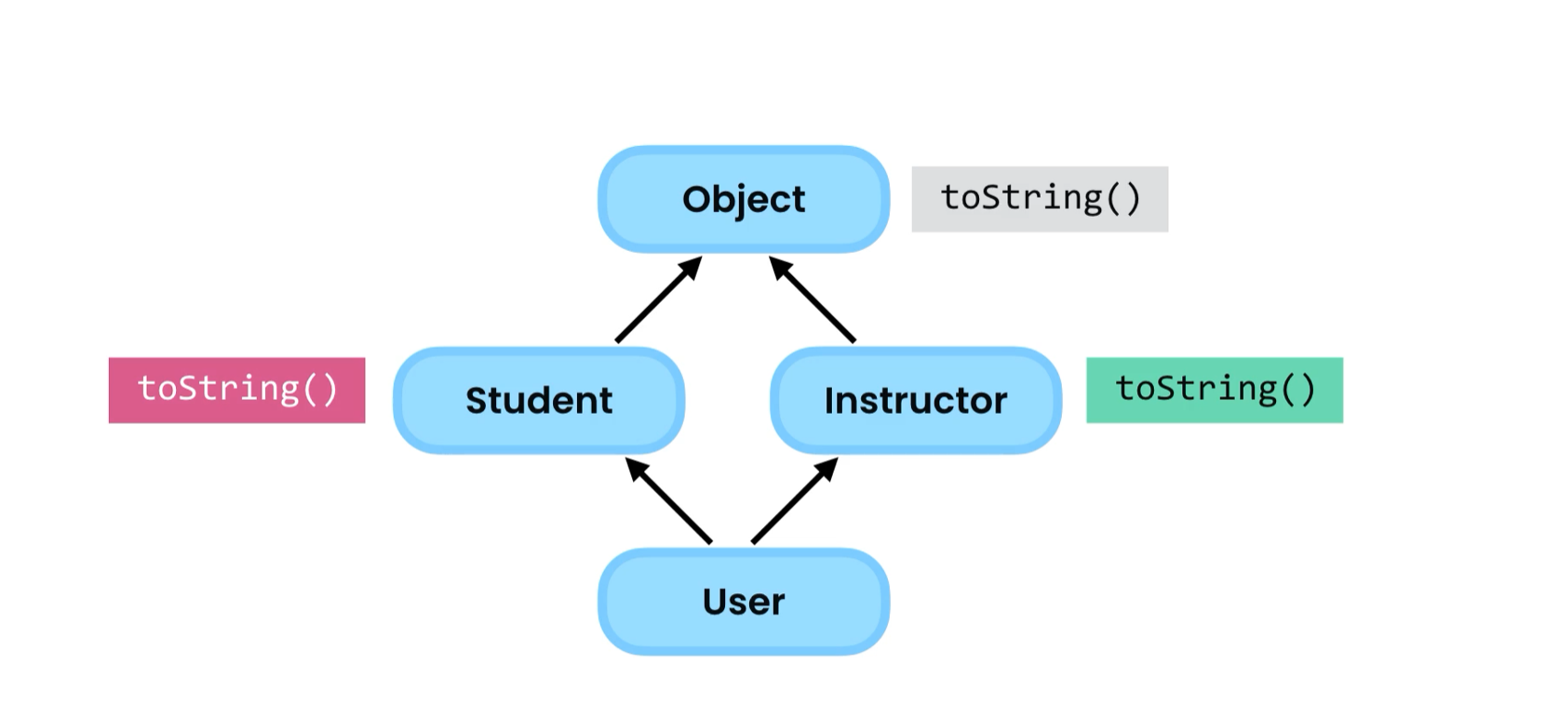

# INTERFACES

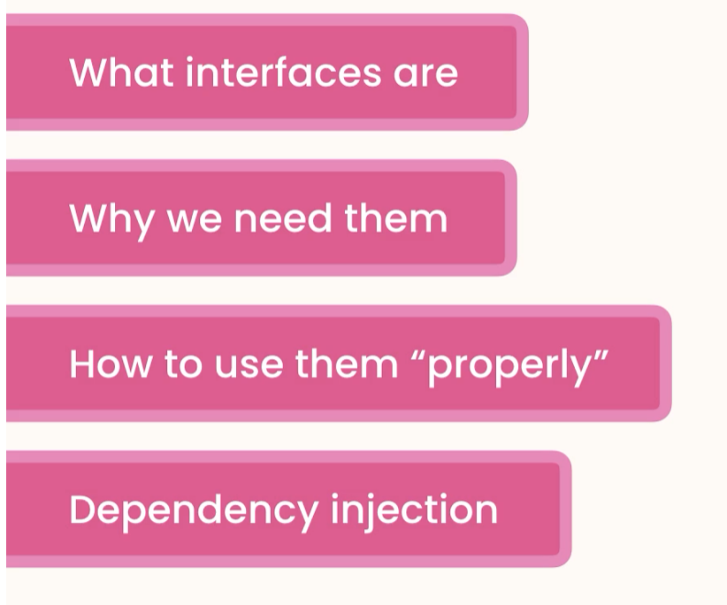

## What are interfaces?



If class A used B

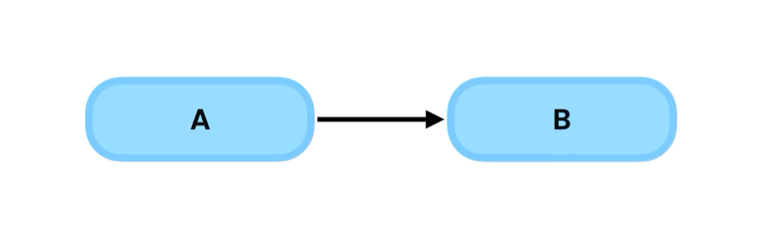

We say class A is dependent or coupled to B, if we change B we might have to change A and all the classes that depends of A.

------------------------------------------------------------------------------------------------------------------------------------------

To decouple A from B we put and interface between them, interface defines the capabilities of a class.

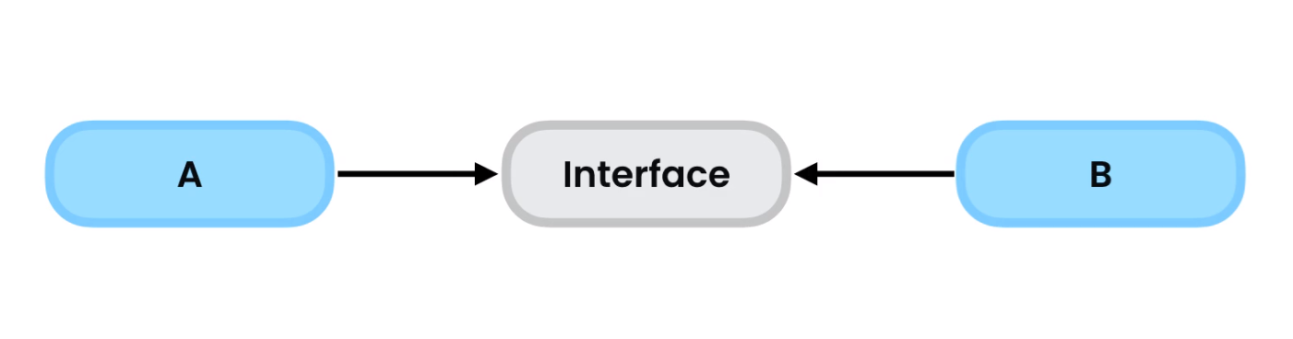

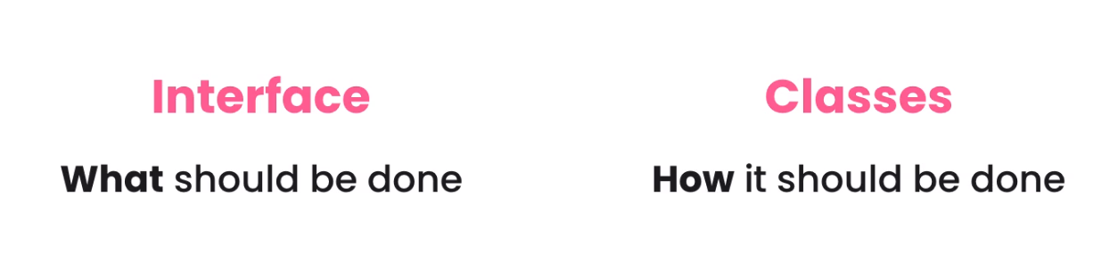

Example of tightly coupled classes:

public class TaxCalculator {  
 private double taxableIncome;  
  
 public TaxCalculator(double taxableIncome) {  
 this.taxableIncome = taxableIncome;  
 }  
  
 public double calculateTax(){  
 return taxableIncome * 0.3;  
 }  
}

public class TaxReport {  
 private TaxCalculator calculator;  
  
 *// constructor* public TaxReport(){  
 this.calculator = new TaxCalculator(100_000);  
 }  
  
 public void show(){  
 var tax = calculator.calculateTax();  
 System.*out*.println(tax);  
 }  
}

TaxReport is tightly coupled with TaxCalculator class. BAD PRACTICE, any changes made to TaxCalculator will affect TaxReport

## Creating an Interface

public interface TaxCalculator {  
 double calculateTax();  
}

---------------------------------------------------------------------------------------------------

public class TaxCalculator2018 implements TaxCalculator{  
 private double taxableIncome;  
  
 public TaxCalculator2018(double taxableIncome) {  
 this.taxableIncome = taxableIncome;  
 }  
  
 @Override  
 public double calculateTax(){  
 return taxableIncome * 0.3;  
 }  
}

## Dependency Injection



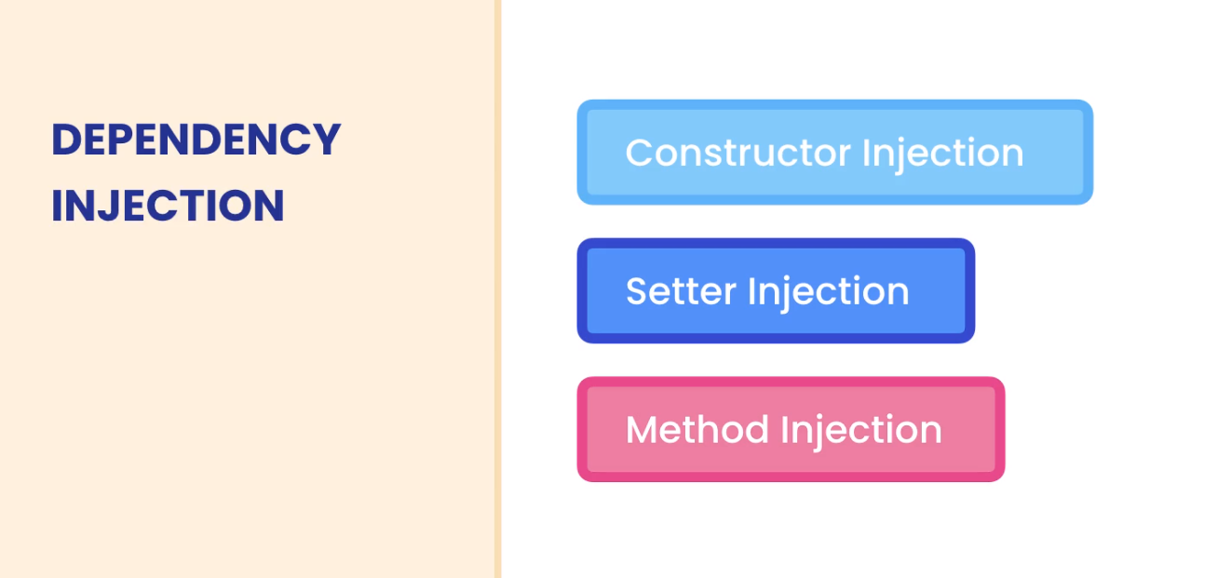



1. We create interface that defines what the class that implements it must do.

public interface TaxCalculator {  
 double calculateTax();  
}

-----------------------------------------------------------------------------

1. Make the class to implement the interface and override its methods

public class TaxCalculator2018 implements TaxCalculator{  
 private double taxableIncome;  
  
 public TaxCalculator2018(double taxableIncome) {  
 this.taxableIncome = taxableIncome;  
 }  
  
 @Override  
 public double calculateTax(){  
 return taxableIncome * 0.3;  
 }  
 }

-----------------------------------------------------------------------------

1. Inject the dependency to the class via constructor using the interface and not the class that implements it.

package ca.adrian;  
  
 public class TaxReport {  
 private TaxCalculator calculator; *// interface  
  
 // constructor, dependency injection by the constructor* public TaxReport(TaxCalculator calculator){  
 this.calculator = calculator;  
 }  
  
 public void show(){  
 var tax = calculator.calculateTax();  
 System.*out*.println(tax);  
 }  
}

-----------------------------------------------------------------------------

1. Pass the class as argument to the constructor.

public static void main(String[] args) {  
 var report = new TaxReport(new TaxCalculator2018(100_000));  
 report.show();  
}

-----------------------------------------------------------------------------



By using setter injection, we change the dependency of a class throughout the lifetime of our application.

Any other class that implements the same interface can be used for dependency

Example:

public class TaxCalculator2019 implements TaxCalculator{  
  
 @Override  
 public double calculateTax() {  
 return 0;  
 }  
 }

-----------------------------------------------------------------------------

public static void main(String[] args) {  
 var calculator2018 = new TaxCalculator2018(100_000);  
 var report = new TaxReport(calculator2018);  
 report.show();  
  
 report.setCalculator(new TaxCalculator2019());  
 report.show();  
}

Here both classes implements the same interface declared in TaxReport that has a dependency in both classes.

## Method Injection

We pass the dependency by the method as an argument

**Parameter:** Interface

**Argument:** Class that implements it

------------------------------------------------------------------------------------------------------------------------------------------

public class TaxReport {  
   
 public void show(TaxCalculator taxCalculator){  
 var tax = taxCalculator.calculateTax();  
 System.*out*.println(tax);  
 }  
   
}

TaxCalculator is an Interface

------------------------------------------------------------------------------------------------------------------------------------------

public static void main(String[] args) {  
 var calculator2018 = new TaxCalculator2018(100_000);  
 var calculator2019 = new TaxCalculator2019();  
 var report = new TaxReport();  
 report.show(calculator2018);  
 report.show(calculator2019);  
}

------------------------------------------------------------------------------------------------------------------------------------------

Must of the time we pass the dependency injection in the constructor cause we can quickly see the dependencies of a class.

## Interface Segregation Principle



By doing so we can reduce the impact of changes

Interfaces can extend multiple interfaces

Project -MyTube Video Platform

My Solution: <https://github.com/adrian3914/Mosh-Java-II/tree/main/MyTube>

------------------------------------------------------------------------------------------------------------------------------------------

## New feature of Interfaces **BAD TO USE**

## Fields

Fields declared in an interface are a constant and static, these fields will be public so no abstraction accomplished.

## Static Methods

The problem with static methods is that contains implementation -LOGIC this can change in the future and break classes that implement it.

Interfaces are about **WHAT** and no **HOW.**

We can reuse some logic if required using abstract classes and defining the access modifier as protected so the children that inherited the members can have access to it.

------------------------------------------------------------------------------------------------------------------------------------------

## Interfaces and Abstract Classes

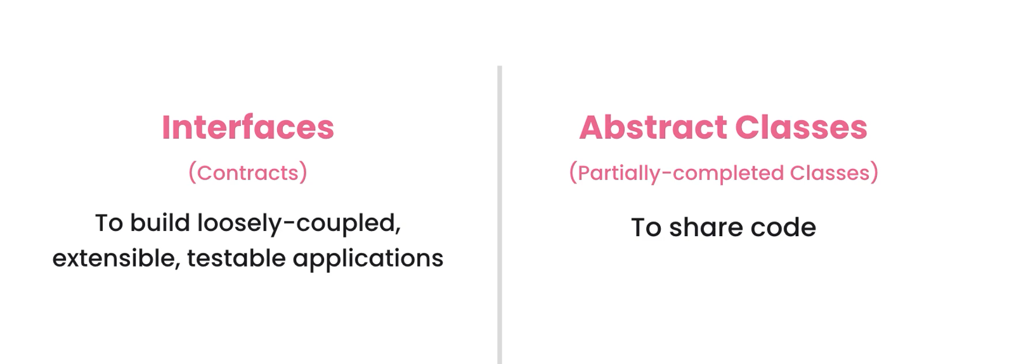

## When to use interfaces

We use interfaces when we want to de-couple class dependency

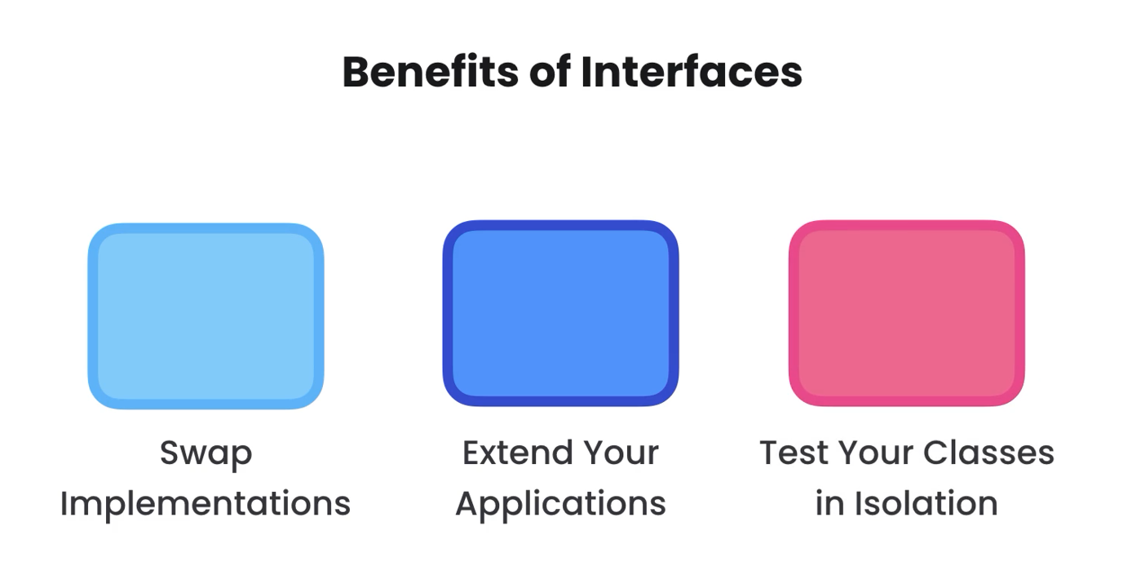

**Tightly coupled**

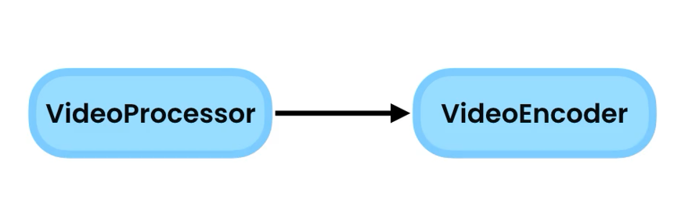

**Decoupled using an interface**

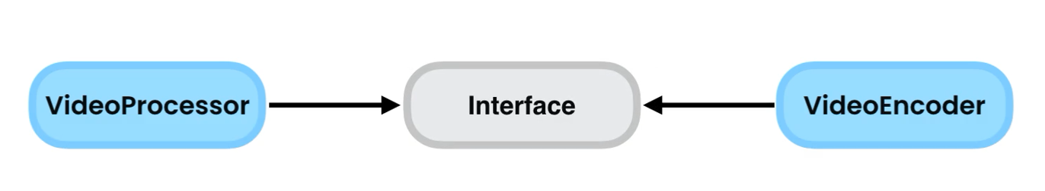

**------------------------------------------------------------------------------------------------------------------------------------------**

**Testing in isolation**

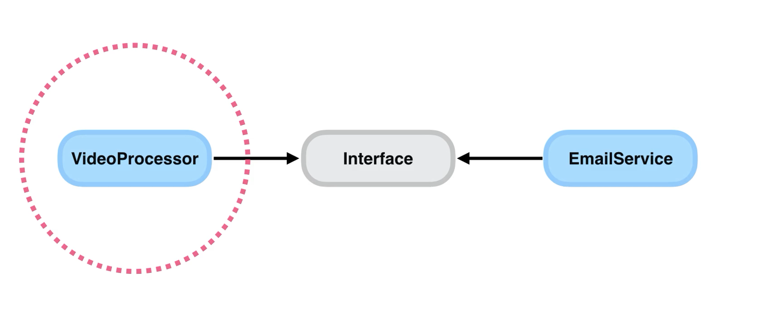

**------------------------------------------------------------------------------------------------------------------------------------------**

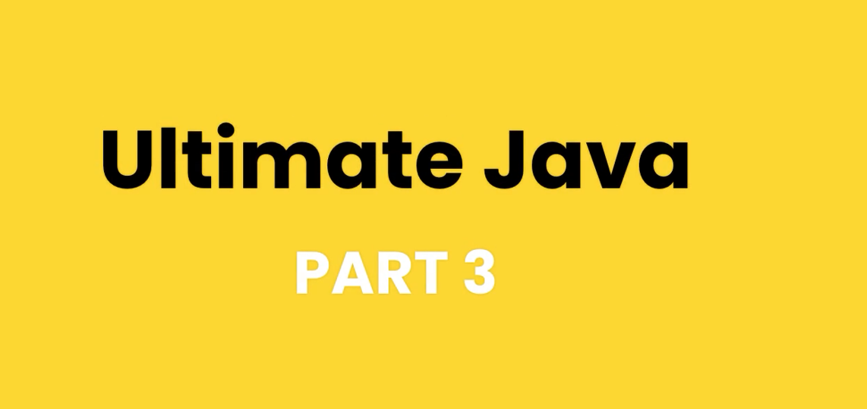

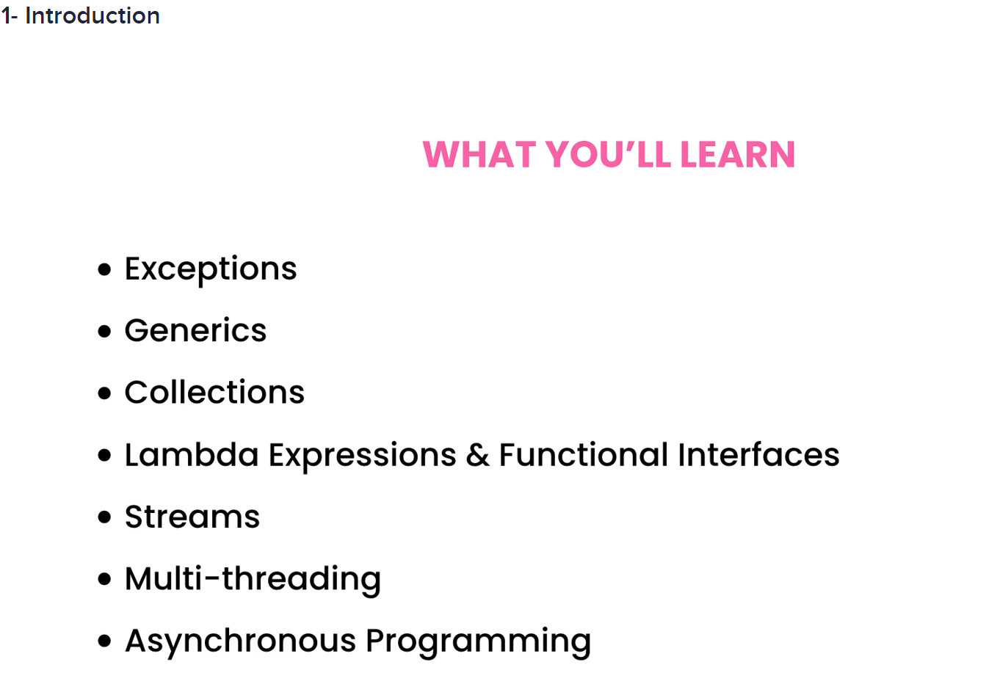



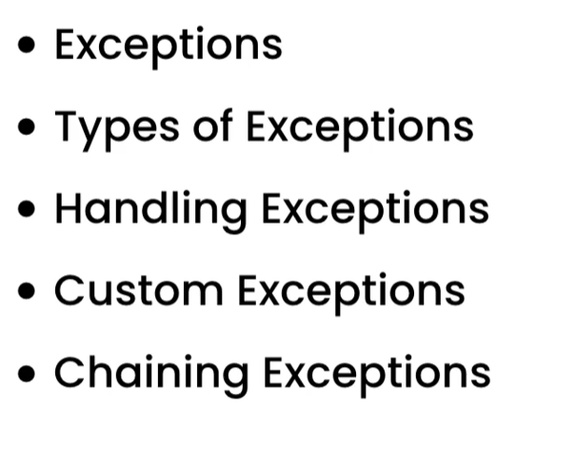

## What are Exceptions?

An exception is an object that contains information about an error.

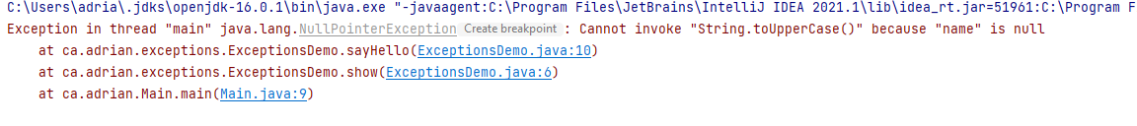

In the above example NullPointerException is the object, and below we can see the stack trace, methods calls.

When an exception happens in a method we say, the method threw an exception. When this happen the java runtime looks of a block of code that handles the exception. If it does not find it, it goes to the previous method.

## Types Of Exceptions



**Checked Exceptions ->** Developer should anticipate them. Java compiler checks them at compile time and advise you.

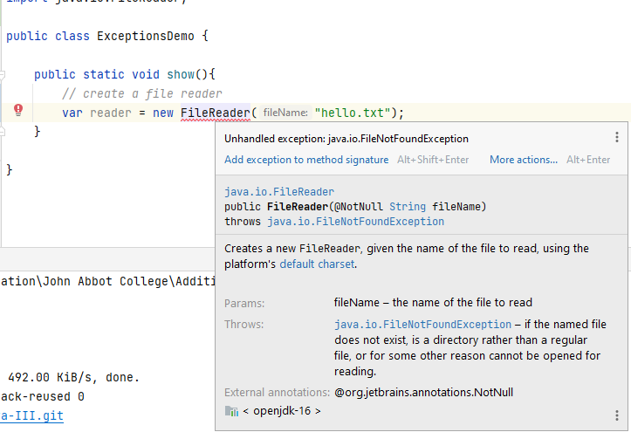

------------------------------------------------------------------------------------------------------------------------------------------



Unchecked Exceptions || Runtime exceptions -> not checked at compile time.

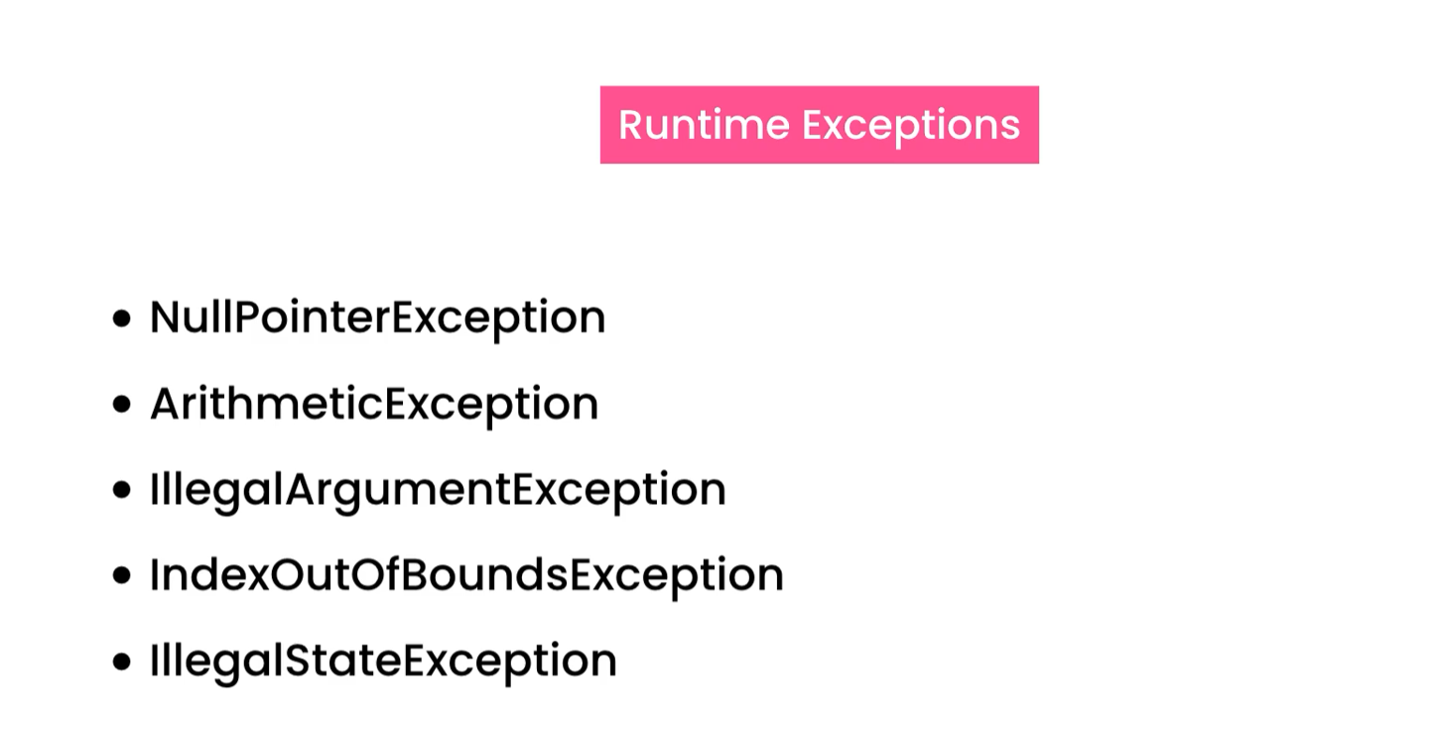

------------------------------------------------------------------------------------------------------------------------------------------

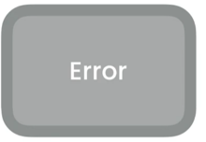

External error

* Stack overflow error
* Out of memory error

------------------------------------------------------------------------------------------------------------------------------------------

## Exceptions Hierarchy

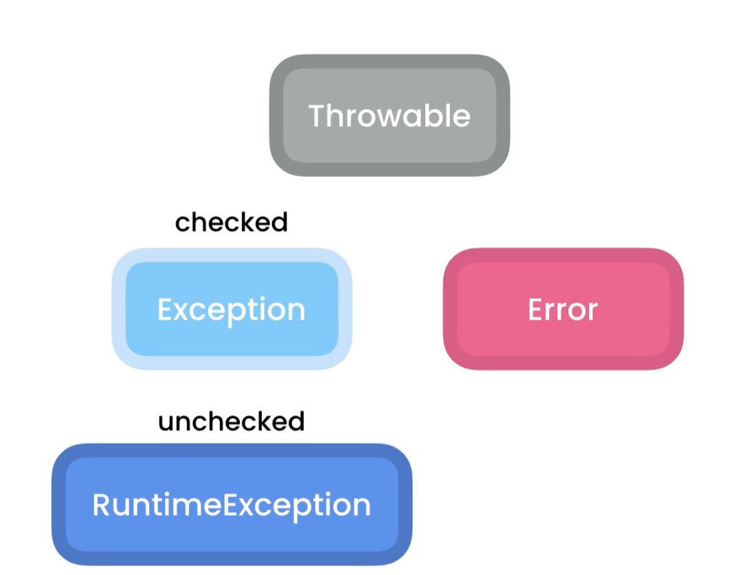

**NullPointerException hierarchy**

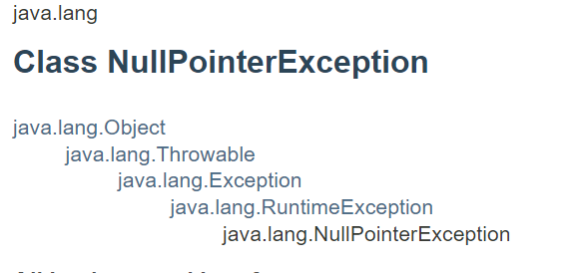

## Catching Exceptions

We use try and catch blocks

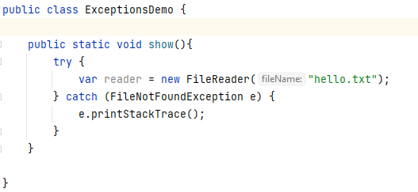

## Catching Multiple Types of Exceptions

We can:

Add multiple catch exception

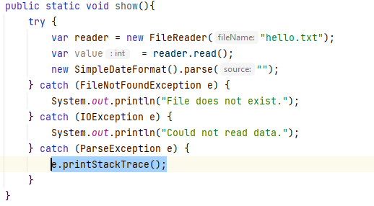

Add multiple exceptions using |

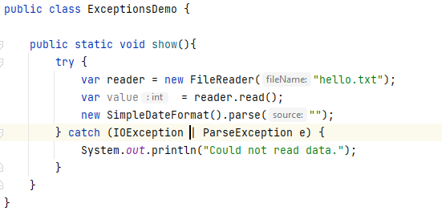

## The Finally Block

try{}

catch{}

finally{} -> this will always get executed, exception or not

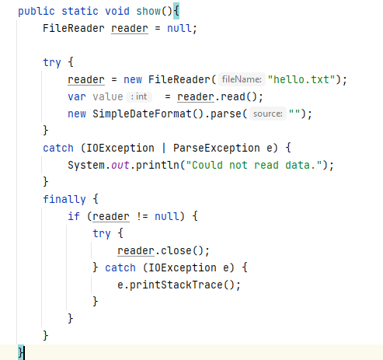

## The try-with-resources Statement

try( FileReader reader = new FileReader(“hello.txt”))

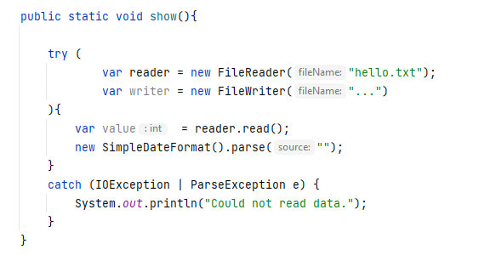

## Throwing Exceptions

Technique of throwing exceptions are called defensive programming.

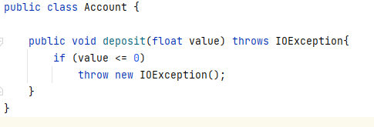

By adding throws keyword to the method signature will tell whoever calls it that this method throws an exception.

## Re-throwing Exceptions

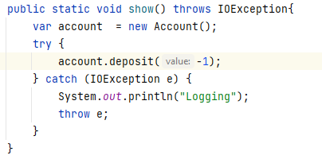

In this case we are handling an exception and re-throwing it to whoever calls this method

So we throw e and add throws to method signature

## Customs Exceptions

Sometimes we need to create customs exceptions specific to our application domain.

1. We create a class that extends Exception or RunTimeException depending on the exception type.

* Check -> Exception
* Unchecked (Runtime) -> RunTimeException

1. Create a constructor and call the parent constructor using keyword.

Example: **creating the custom exception**

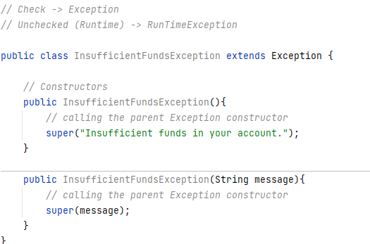

**Using our Custom Exception**

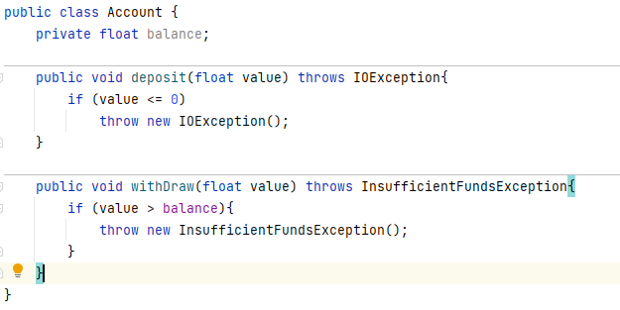

Handling the exception

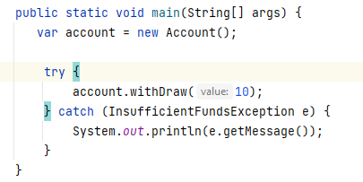

## Chaining Exceptions

We wrap an exception on another

Example:

**More Generic Exception**

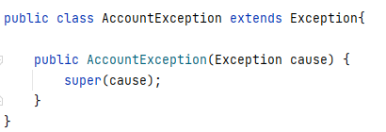

**Exception that causes it**

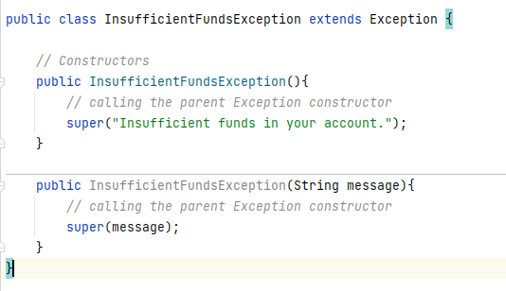

**Where Exception is thrown**

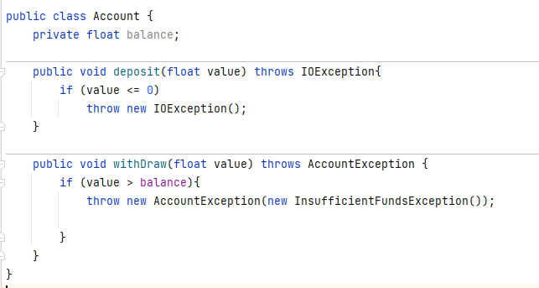

**Handling Exception**

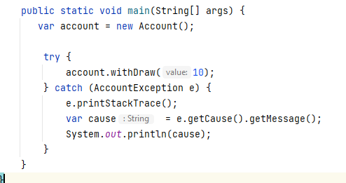

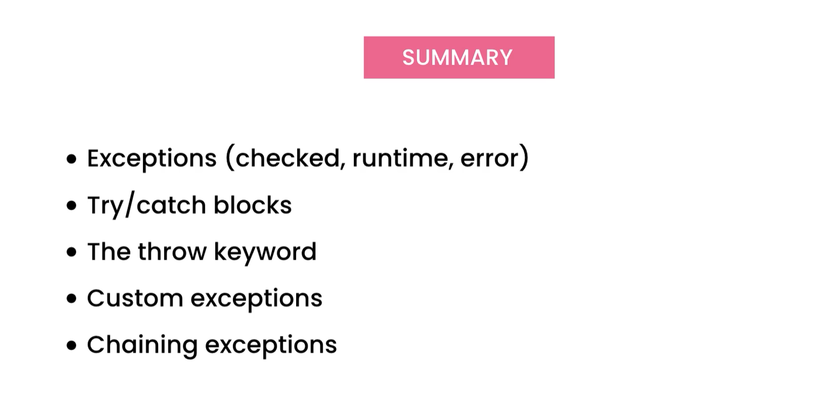



**The List Class accepts items only of type int. We want to be able to add different items type, we use generics**

------------------------------------------------------------------------------------------------------------------------------------------

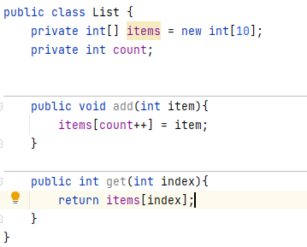

------------------------------------------------------------------------------------------------------------------------------------------

## Poor Solution

We can use Object[] since all the reference type derives from object so we can pass any data type, we can even pass primitive type and the compiler will implicit cast it to its wrapper class which is a reference type, int -> Integer, float -> Float, etc.

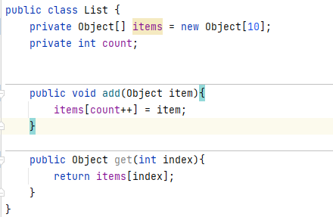

------------------------------------------------------------------------------------------------------------------------------------------

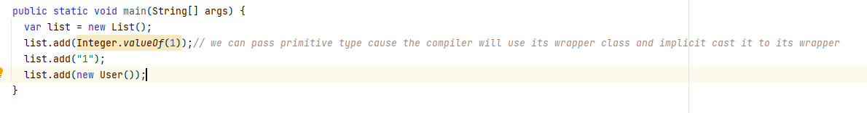

------------------------------------------------------------------------------------------------------------------------------------------

### Problems with this implementation



Exception





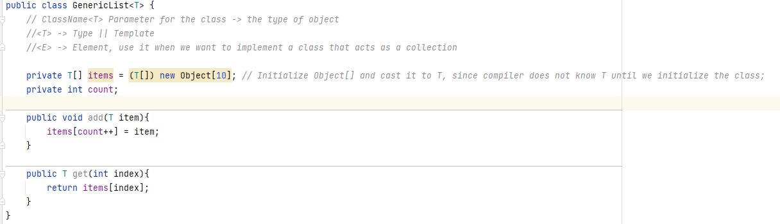

When initializing the class we pass the T-> Type

**Integer**

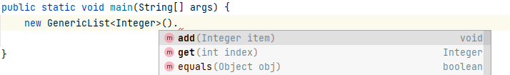

------------------------------------------------------------------------------------------------------------------------------------------

**Float**

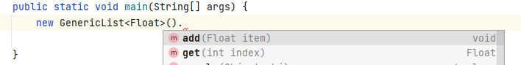

By the use of generics, we will get compile type error

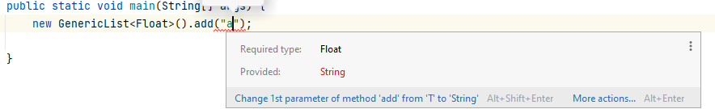

We can instantiate the class with any type

**Integer**

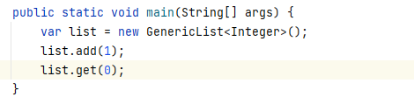

**User**

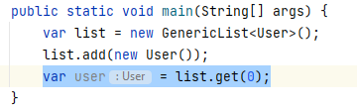



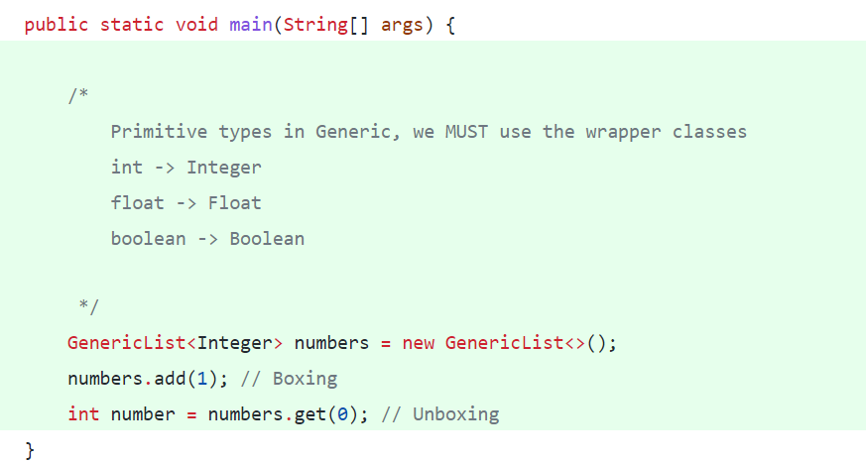



**There are times we want to add a constraint or restriction to a Type parameter**

If want to use only number, we use inheritance from Number

Example:



T can be only of number type

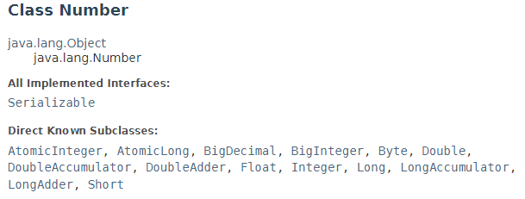

Subclasses of Byte, Double, Float, Short, etc. are children of Number.

We can only pass its subclasses or itself

Example:

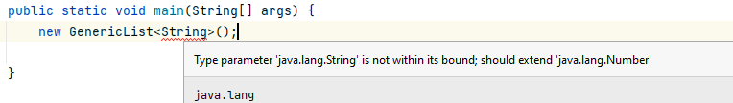

**Float**

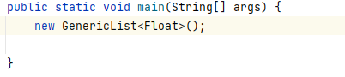

**The constraint can be also an interface, now we can pass only classes that implement the Comparable interface.**



**>>>>>>>>>>>>>>>>>>>>>>>>>>>>>>>>>>>>>>>>>>>>>>>>>>>>>>>>>>>>>>>>>>>>>>>>>>>**

**We can pass User**

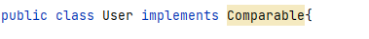

------------------------------------------------------------------------------------------------------------------------------------------

**We can extend multiple interfaces; we can pass only classes that implement the interfaces.**



**>>>>>>>>>>>>>>>>>>>>>>>>>>>>>>>>>>>>>>>>>>>>>>>>>>>>>>>>>>>>>>>>>>>>>>>>>>>**

**We cannot pass User anymore in this case since extends two interface and user implements only one**

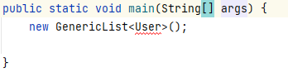



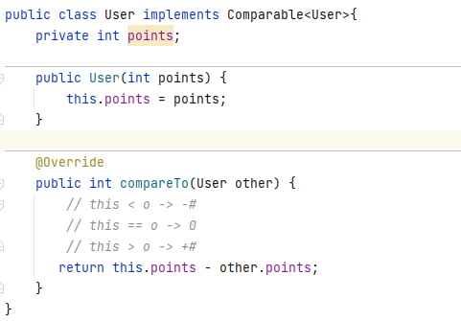

**Comparing in Main**

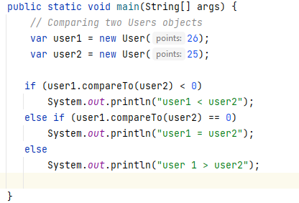



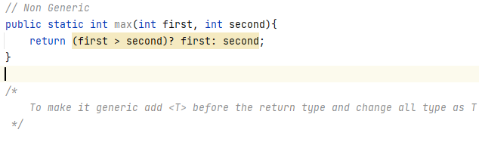

---------------------------------------------------------------------------------------------------------------------------------------

Example:

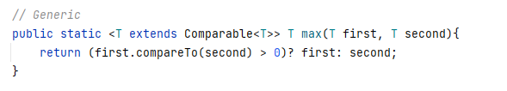

We add the constraint of Comparable Interface to be able to pass classes that implement the interface and compare objects.

---------------------------------------------------------------------------------------------------------------------------------------

**Using the Generic method**

**Passing User**

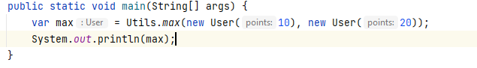

**Passing an integer**

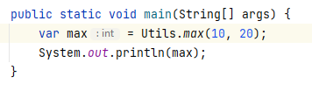



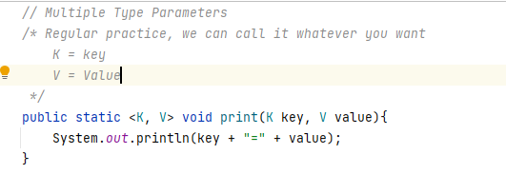

**Main**

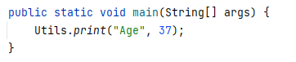

**Multiple Type Parameters in a Class**

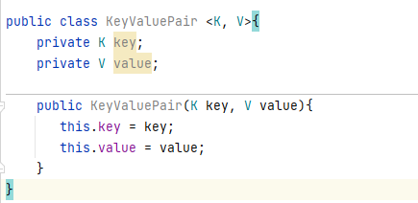



? -> Wild character, Unknown type. When use we can pass anything

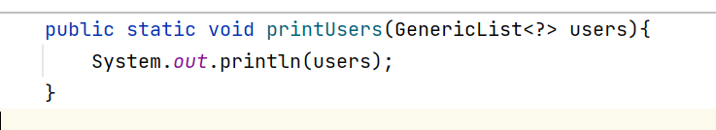

Int this case we can pass a GenericList of any type.

When we use a wild char the java compiler will create an anonymous class type under the hood

 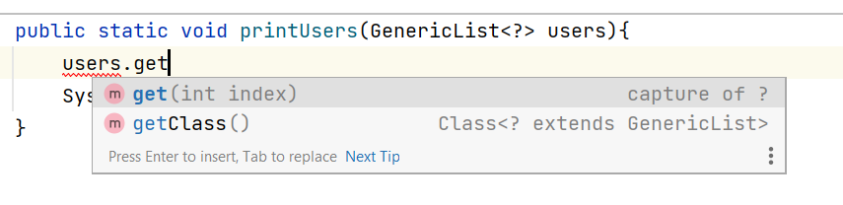

get() returns an instance of capture class (anonymous)

------------------------------------------------------------------------------------------------------------------------------------------

In order to limited we add a constraint either extends class || interface, this way all of sub-types classes and all classes that implement such interface can be passed.



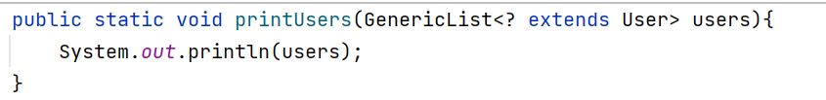

When the compile see the constraint makes the anonymous class one of User subtypes

extends **: YOU CAN READ**

**makes the capture anonymous class extend the class**

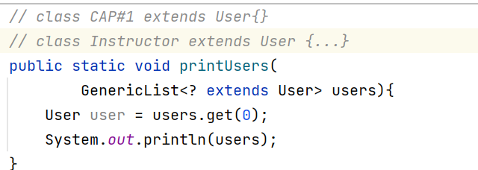

super**: YOU CAN ADD**

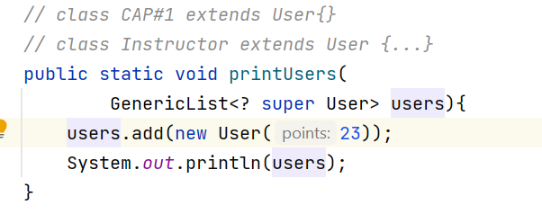

**When the compiler see expression **

**It will treat it as the parent of the User -> Obj**

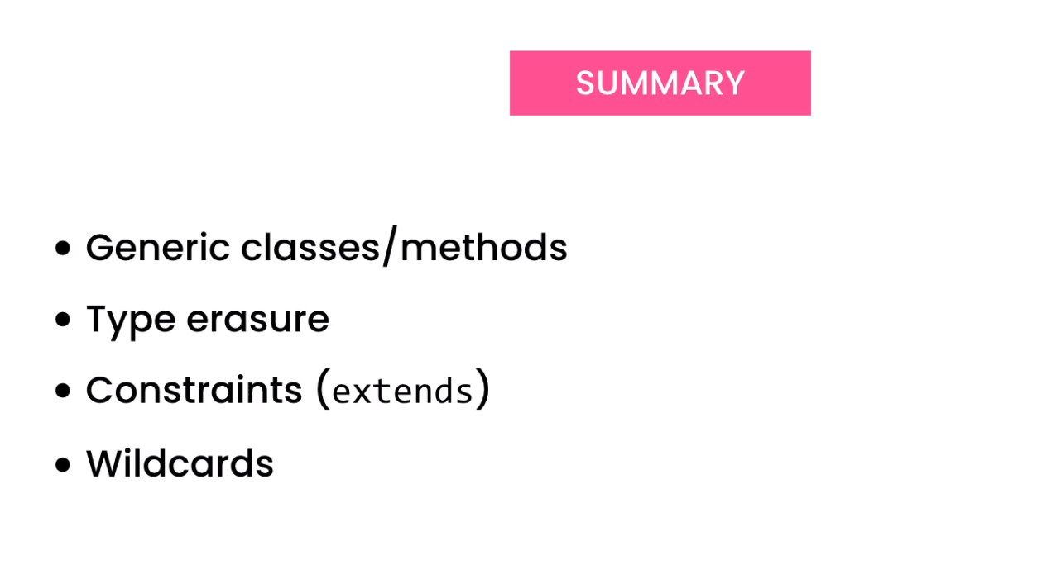





Green Interfaces

Blue classes that implement them

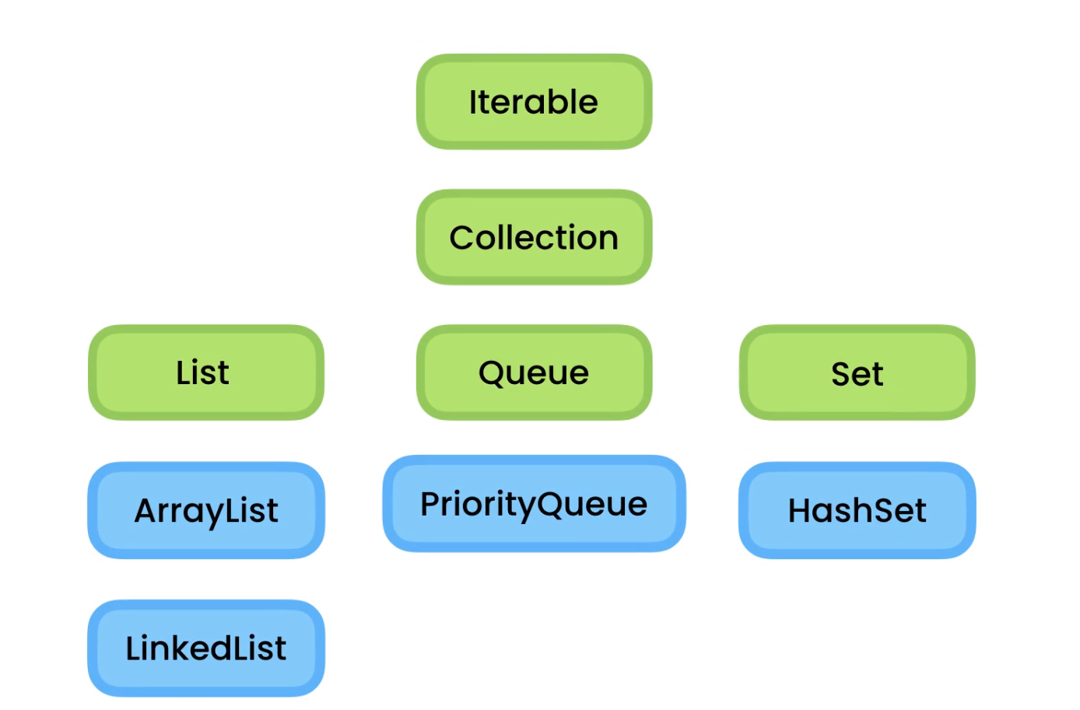



…



The Iterable interface represents an object that is Iterable, it means we can iterate or loop over it without knowing anything about its implementation details.

We implement the iterable interface in the class.



We declare a nested class, so when changes are made to the data structure like [] instead of ArrayList, only the nested class will be affected.

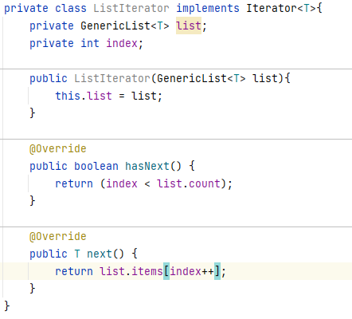

Override method of Iterable interface

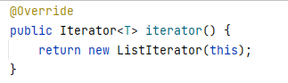



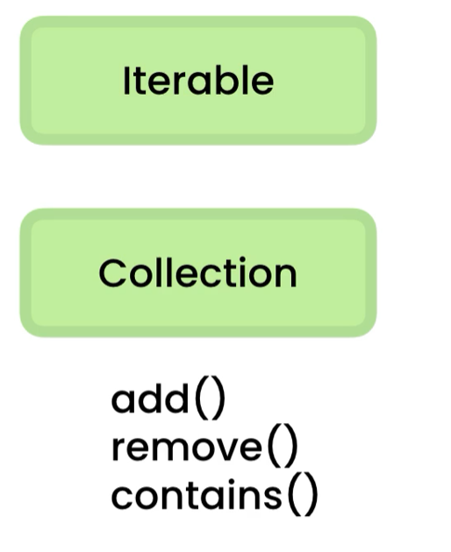

The collection interface represent a container for an object that is a collection or container for other objects.

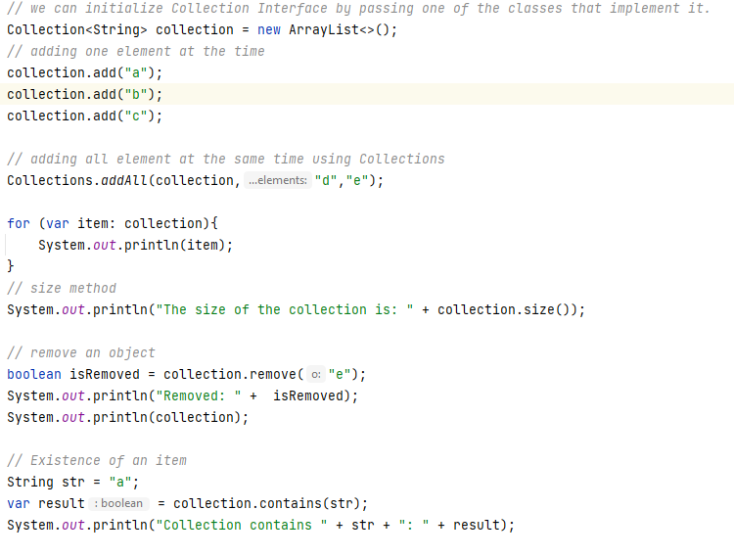

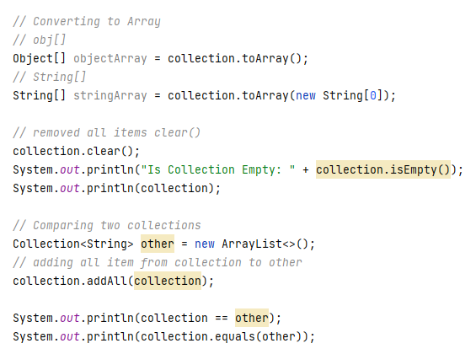



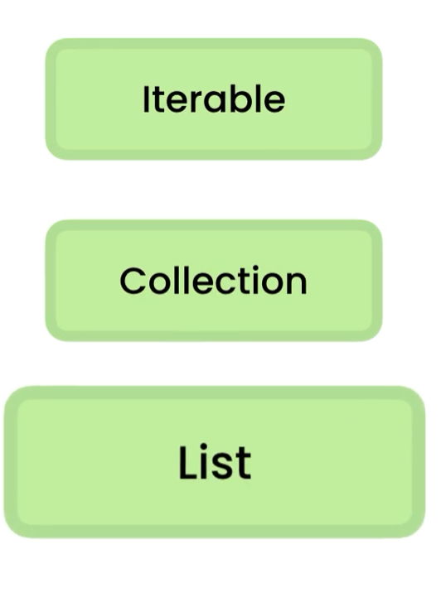

The List interface represent an order collection also called a sequence, so we have access by its index, here we have access to all methods, in collection and iterable interfaces as well.

We Initialize the List<> as follow: 

Here we pass ArrayList<>() class since implements List<> interface Dependency Injection in action.

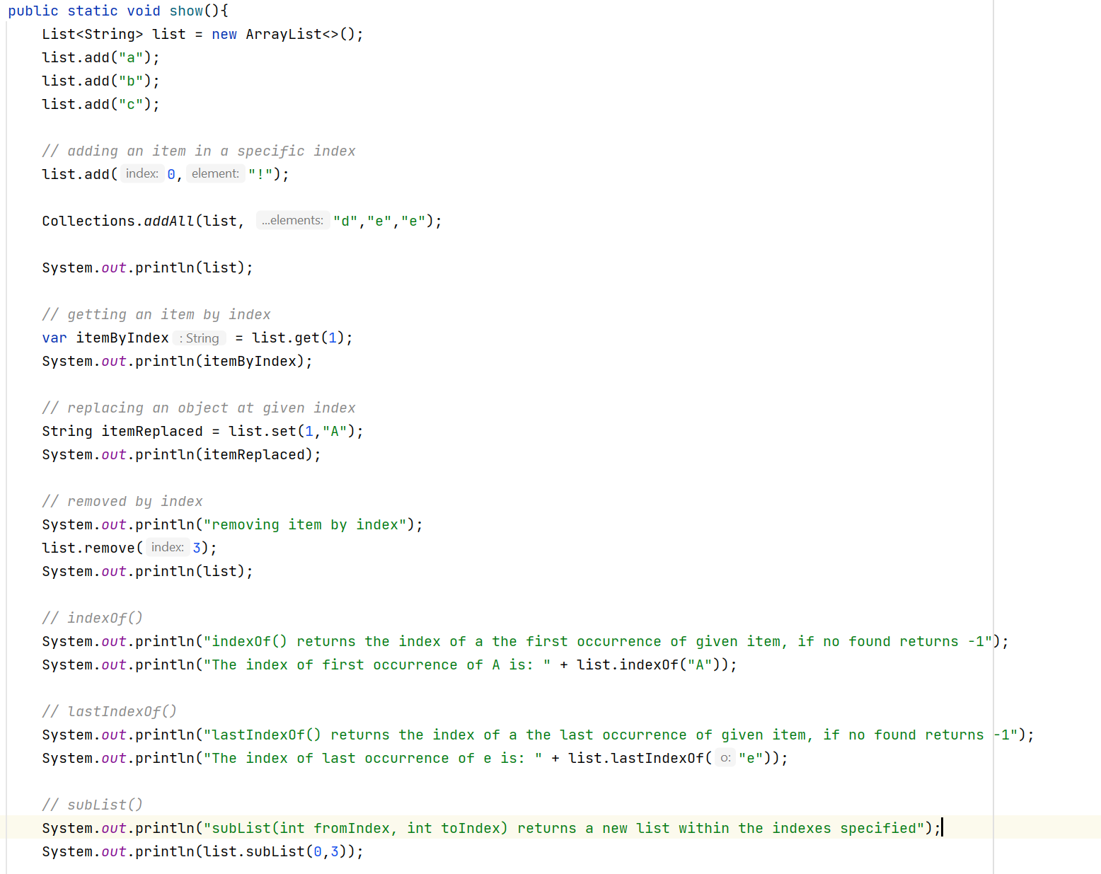



Sorting Data using the comparable Interface.

To sort data using the comparable interface, the class must implement the comparable interface, override the method compareTo().

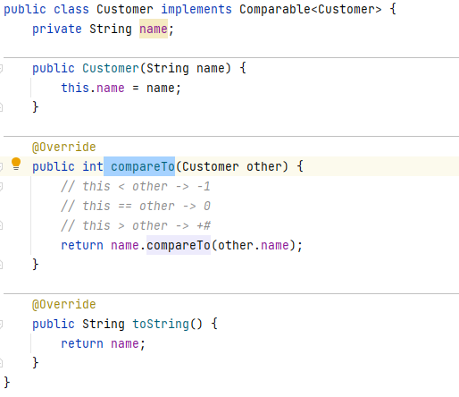

Main:

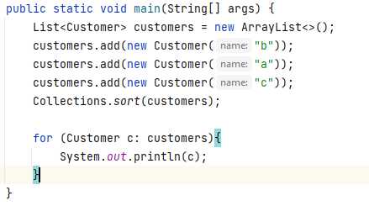

OUTPUT:

a

b

c



To compare objects using the Comparator Interface

We make a new class that implements Comparator<> interface and override the method

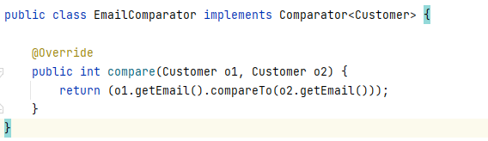

Now we can call Collections.sort()



We pass list and Comparator

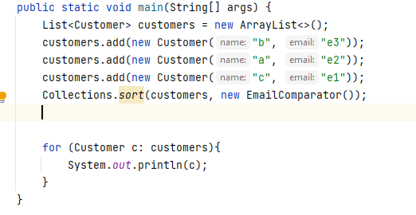

OUTPUT

c

a

b



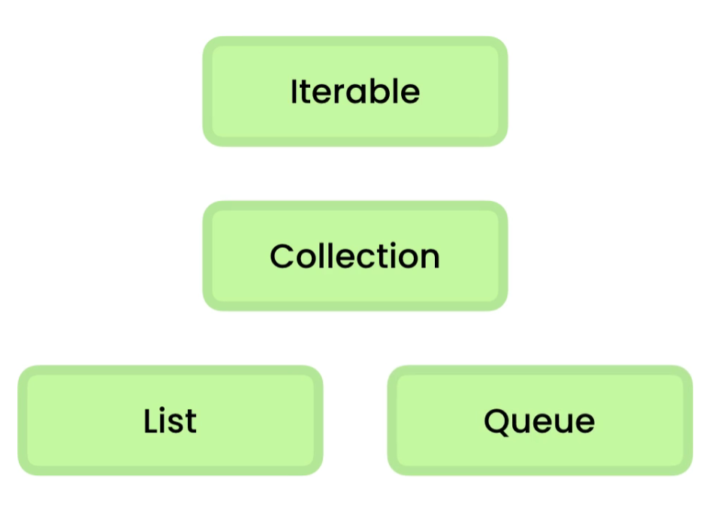

We use queues when we want to process jobs based on the order, we received them. Think like a printer.

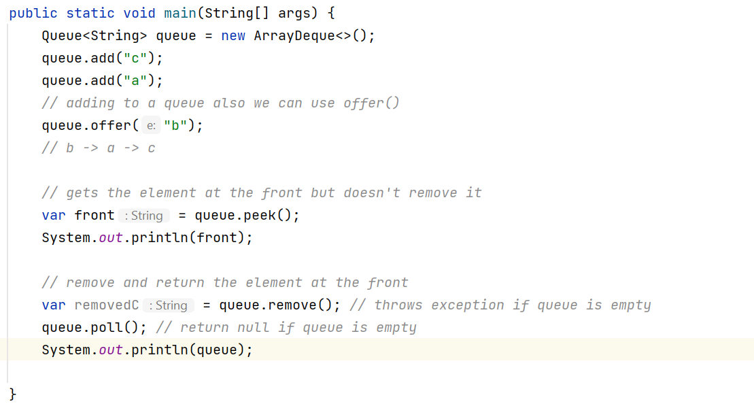



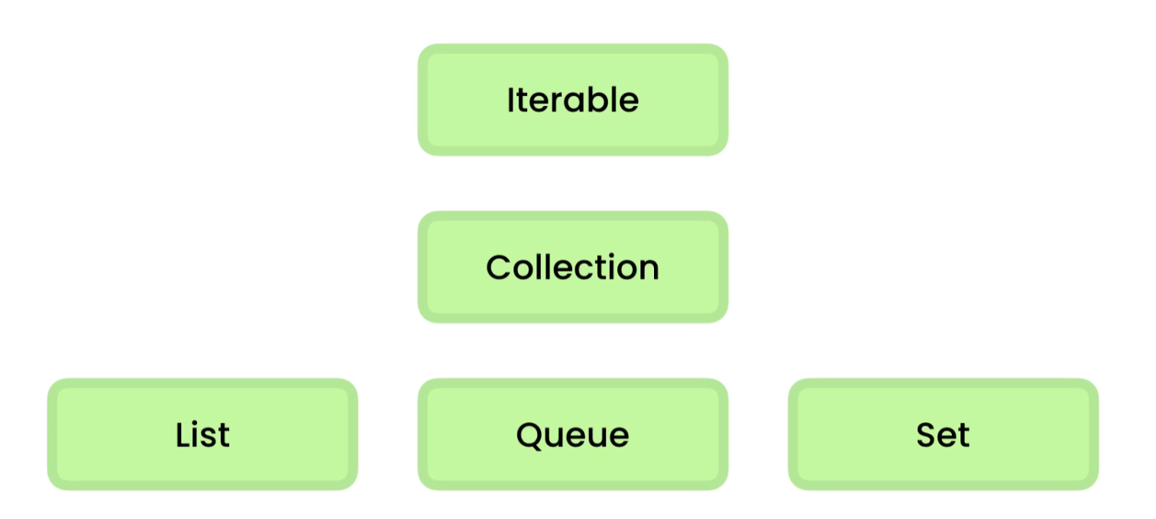

The set interface contains a collection with no duplicates. Great to store a set of unique values

A set does not guarantee the order of items, only that contains unique values.

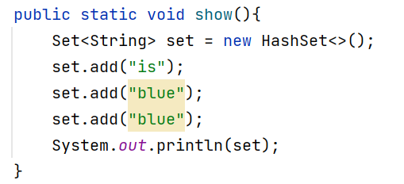

OUTPUT: [blue, is]

There 4 operations in a set that we need to understand.

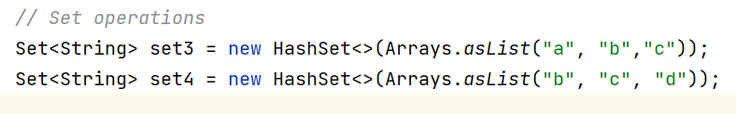

UNION

Add both sets only values that are not repeated

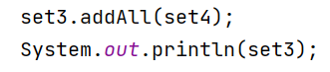

**OUTPUT: [a, b, c, d]**

**---------------------------------------------------------------------------------------------**

INTERSECTION

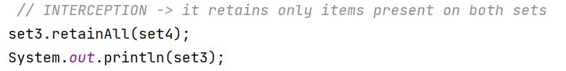

**OUTPUT: [b, c, ]**

DIFFERENCE

To know what items, we have in the first set that we do not have in second.

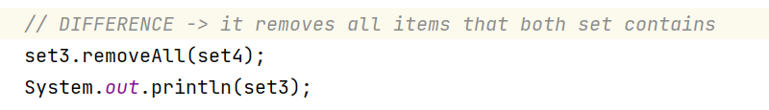

OUTPUT: [a]

REMOVING DUPLICATES

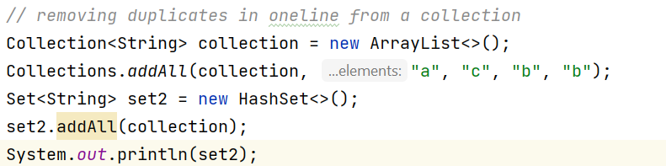

OUTPUT: [a, b, c]



A hash table is a special data structure, so we can use it to store data, the way it stores the data is different from how a list of array stores data. We can quickly look for an object no matter how many objects we have stored. We can find the customer using only one comparison -> O(1)

**In Java we call hash tables Maps**



The map represents a set of key value pairs.

**Key : value pair**

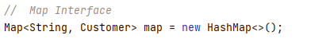

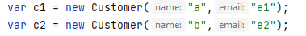

**Methods:**

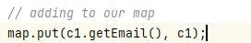

**------------------------------------------------------**



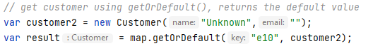

**------------------------------------------------------**

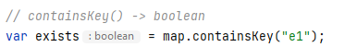

**------------------------------------------------------**



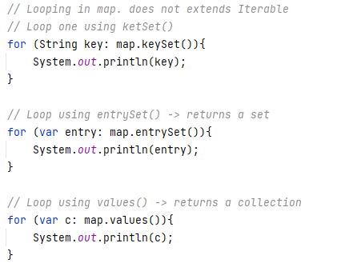

**------------------------------------------------------**

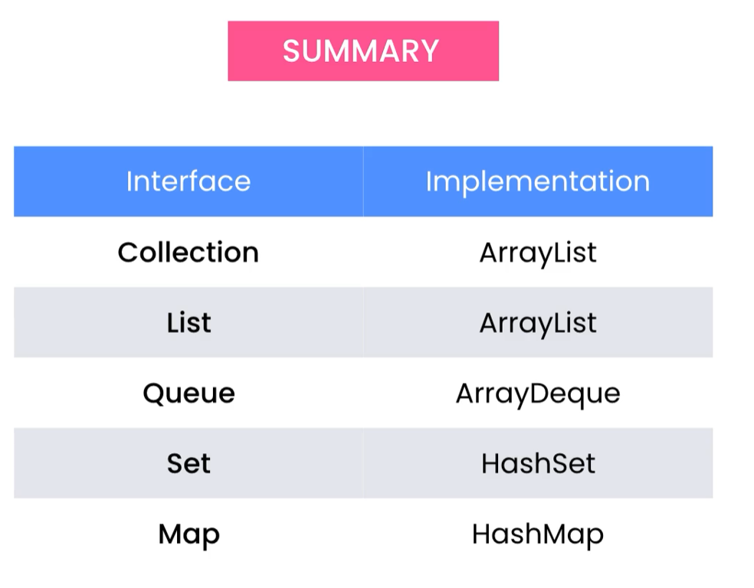



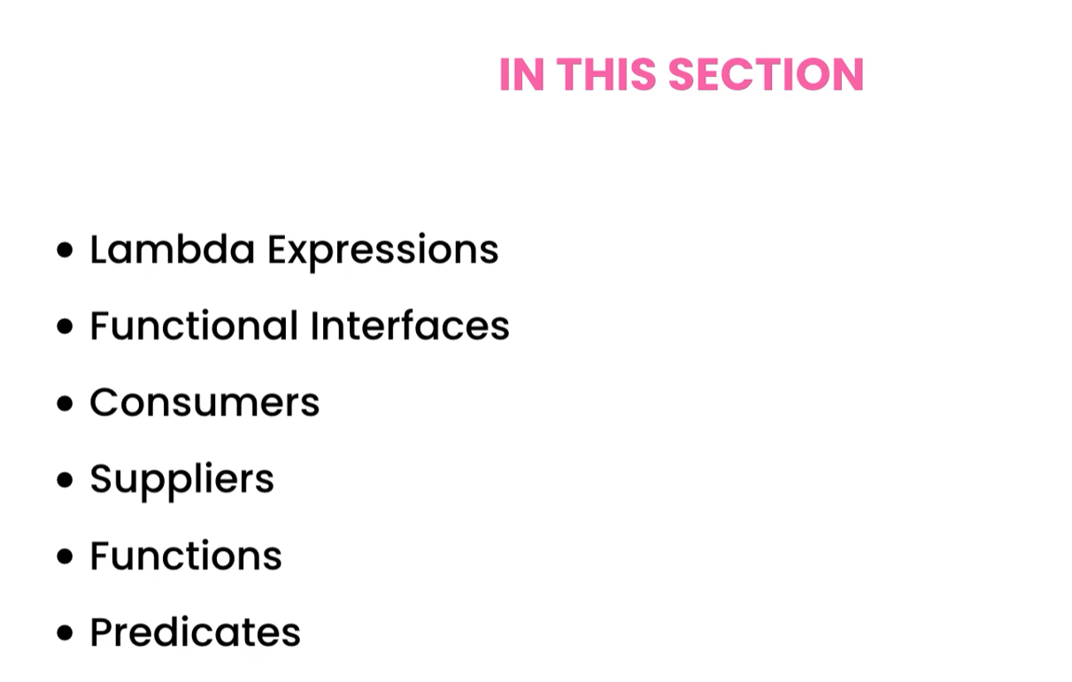



**Functional Interface:** It is an interface with a single abstract method.

Comparable Interface

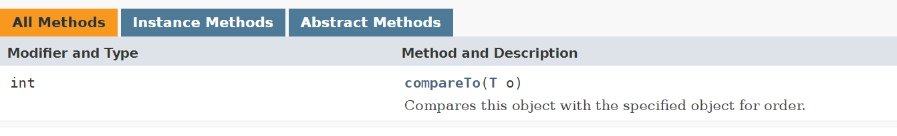

Comparable Interface

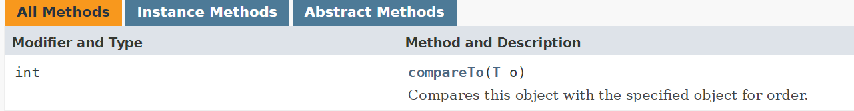

**Functional Interface**

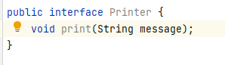

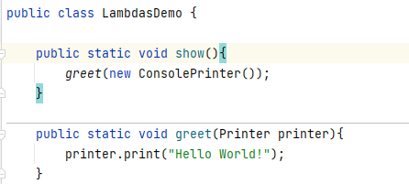

Sometimes we do not want to create a class that implements the interface. So we use anonymous inner classes.



We can use anonymous inner class instead of creating a class that implements the interface.

**Anonymous Class:** Because **the class has NO NAME**

**Inner Class:** Because it is used inside a method

Example:

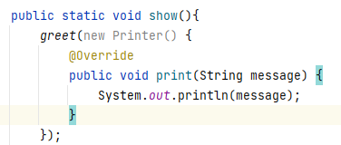

Java introduced a better way to the same called Lambda expression.



Lambda expression is like an anonymous function that we can pass around. A function that stands alone without belonging to a class.

We can implement functional interfaces using lambda expression.

**Syntax:** (Parameters) -> { implementation}

Example:

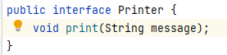

-----------------------------------------------------------

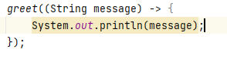

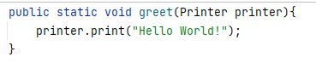

-----------------------------------------------------------

We can remove the type parameter String since the compiler knows the signature of the method in the interface

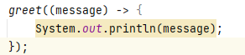

If we have a single parameter, we can remove the parenthesis enclosing the parameters.

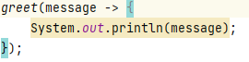

We use () only if we have no parameters or multiple parameters.

* () -> {…}
* (a, b, c) -> {…}

If the body of the lambda expression has only one line of code, we do not need the {}



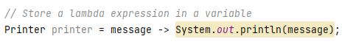

**Lambda expression are objects that we can use to represent anonymous function.**



We can access variables declared

**In the method**

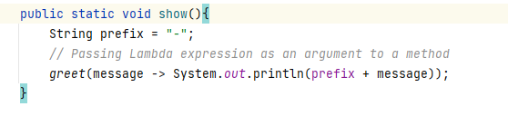

**Static fields declared in the class.**

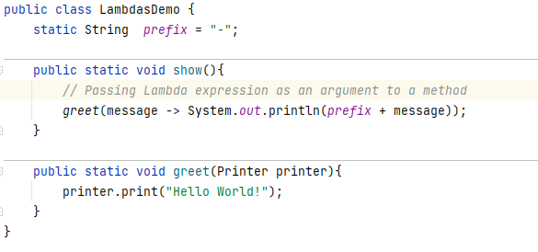

**Instance fields in the method in not static**

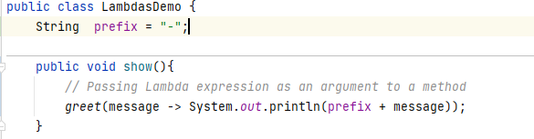

**this**

In a lamnda expression this -> refers to the current object LamdasDemo, in a inner class this refers to the instance of the anonymous class.

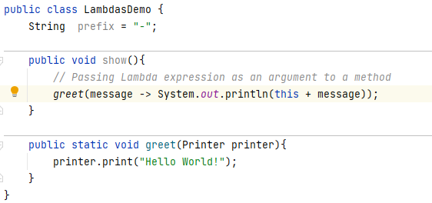

Anonymous inner classes can have fields.